# **UNSW_NB_15 DATASET**

## Model : RandomForest

### Clean Data

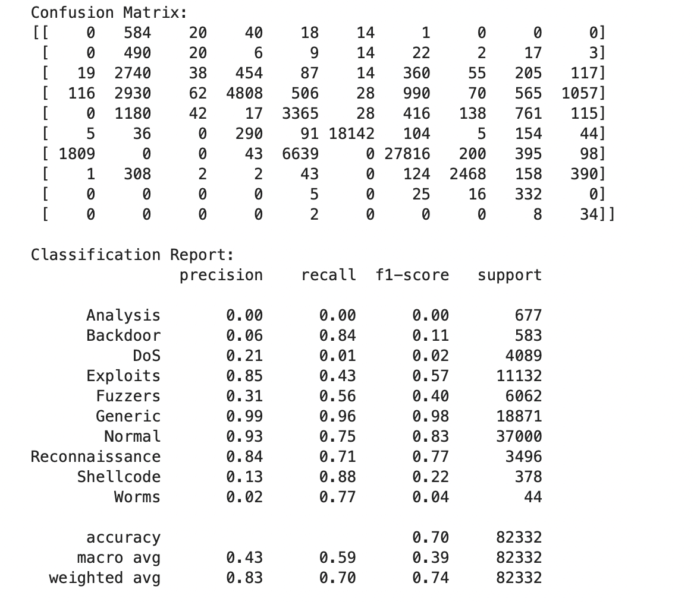

#### Original Classification Report

* **Performance**: The model achieves an overall accuracy of **70%** with a reasonably balanced weighted average F1-score of **0.74**.
* **Strong Classes**: The model performs well on certain classes such as:
  + **Generic**: High precision and recall (0.99 and 0.96, respectively), suggesting the model can reliably identify this class.
  + **Normal**: Precision is high (0.93), but recall is somewhat lower (0.75), indicating the model identifies most normal traffic correctly but misses some instances.
* **Weak Classes**: Some classes have very low precision and recall scores:
  + **Analysis, DoS, Worms**: These classes have very low precision and recall, suggesting the model struggles to detect these attack types accurately.
* **Class Imbalance Effect**: Classes with high support like Normal and Generic heavily influence the weighted averages, as these are better identified by the model.

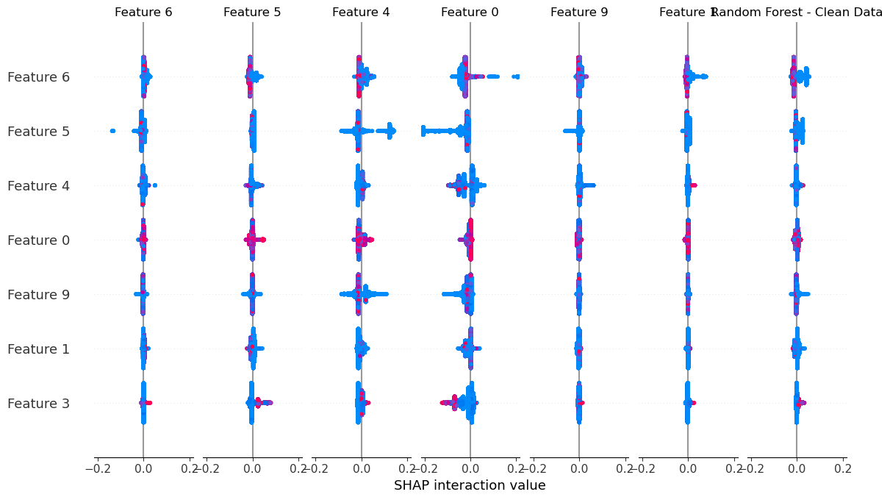

### Boundary Attack

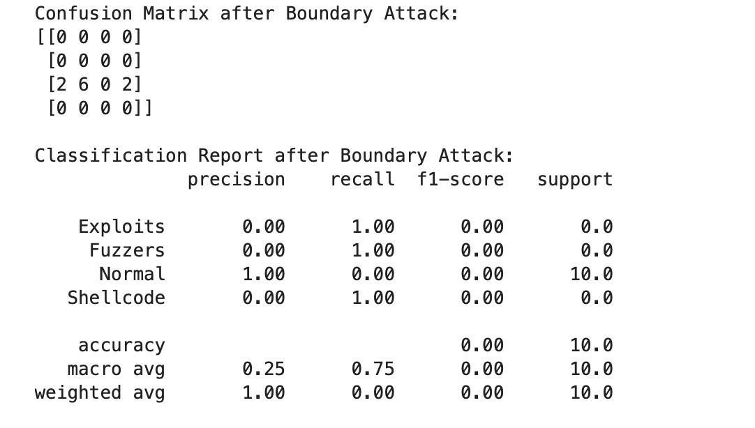

#### Classification Report After Boundary Attack

* **Significant Performance Degradation**: After the Boundary Attack, the model's accuracy drops to **0%**, and it essentially fails to make correct predictions for the majority of the test samples.
* **Class Confusion**:
  + The attack caused the model to misclassify nearly all adversarial samples, as evidenced by the recall scores of 1.0 for Exploits, Fuzzers, and Shellcode, which don’t actually correspond to the original true labels of the samples.
  + The **Normal** class, despite having high precision initially, now has a recall of 0.0, indicating the model fails to recognize even correctly labeled normal samples.
* **Macro and Weighted Averages**:
  + The **macro average** precision is low (0.25), while recall is artificially inflated (0.75) due to the model incorrectly predicting attack labels with high confidence. This further emphasizes the impact of the Boundary Attack in disrupting the model’s ability to discern between classes.
  + The **weighted average** precision of 1.0 is misleading here, as it reflects the zero positive identifications across almost all classes, indicating a severe misclassification rather than reliable performance.

#### Interpretation

1. **Vulnerability to Adversarial Attacks**:
   * The drastic drop in accuracy and F1-score after the Boundary Attack shows that the Random Forest model is highly susceptible to adversarial perturbations.
   * Boundary Attack has successfully manipulated samples to induce misclassifications, particularly impacting classes with low support or less distinct feature patterns.
2. **Loss of Class Discrimination**:
   * Classes such as Normal and Generic, which had high scores before the attack, are now entirely misclassified. This indicates that the adversarial samples have disrupted the model’s learned patterns, making it challenging for the model to distinguish between normal and malicious classes.
   * The model’s high recall for Exploits, Fuzzers, and Shellcode after the attack, despite no true positive samples, highlights a tendency to misclassify adversarial samples into these categories.
3. **Implications for Model Improvement**:
   * **Adversarial Training**: Incorporating adversarial samples in training could improve robustness by helping the model recognize perturbed samples more effectively.
   * **Ensemble or Hybrid Models**: Adding defenses like ensemble learning or hybrid models combining multiple algorithms may help improve resilience against attacks.
   * **Feature Engineering**: Consider revisiting feature selection or engineering to make the model more robust against small perturbations that might target weakly discriminative features.

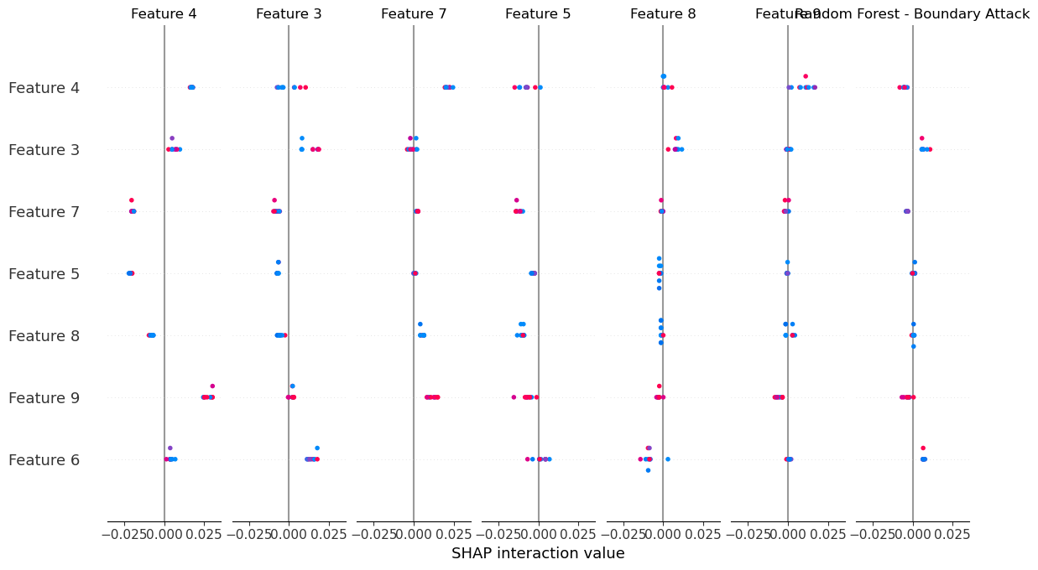

### HopSkiJump Attack

#### After HopSkipJump Attack Performance Summary

* **Overall Performance Drop**:
  + The accuracy dropped to **0%**, and the weighted average F1-score is **0.00**. The model has failed to correctly identify any samples in their original classes after the attack.
* **Class Confusion**:
  + The model heavily misclassifies samples, particularly predicting the Normal class incorrectly 90% of the time.
  + Interestingly, the confusion matrix shows that even though the attack samples were originally from multiple classes, the model only predicted one of them correctly.
* **Macro and Weighted Averages**:
  + **Macro Average**: Precision is low (0.33), and recall is artificially inflated (0.67) due to zero actual positive identifications across almost all classes.
  + **Weighted Average**: Precision is misleadingly high (1.00) due to the complete lack of correct classifications.

#### Key Observations

1. **Model Vulnerability to Adversarial Attacks**:
   * Both the Boundary Attack and the HopSkipJump Attack cause the model's accuracy to drop to zero, highlighting that the model is highly susceptible to adversarial manipulation.
   * In both attacks, the model struggles to classify Normal samples accurately, showing that the adversarial perturbations are effective in confusing the model.
2. **Class-Specific Impact**:
   * Certain attack classes (Exploits, Fuzzers) have zero correct predictions post-attack, suggesting that the model is unable to maintain its decision boundaries under adversarial conditions.
   * The clean data had good performance on majority classes, but adversarial samples have rendered these distinctions meaningless.
3. **Implications for Model Robustness**:
   * **Adversarial Training**: The results emphasize the need for adversarial training to improve robustness against attacks like HopSkipJump.
   * **Class Balance and Regularization**: Handling class imbalances more effectively and using regularization techniques might make the model less sensitive to small perturbations.

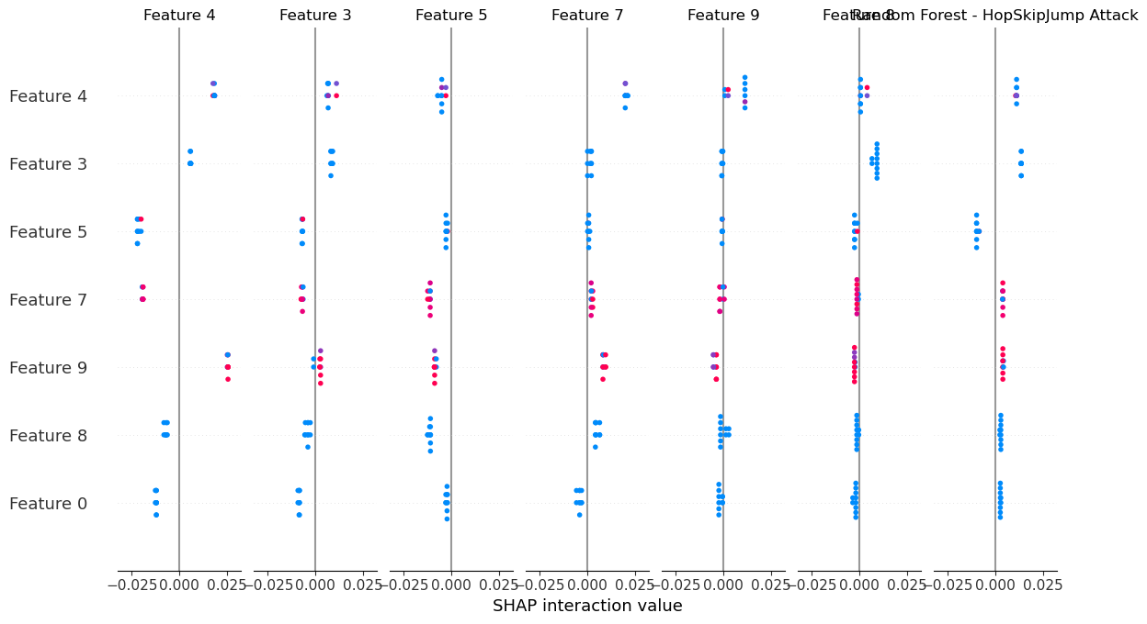

## Model : SVM

### Clean Data

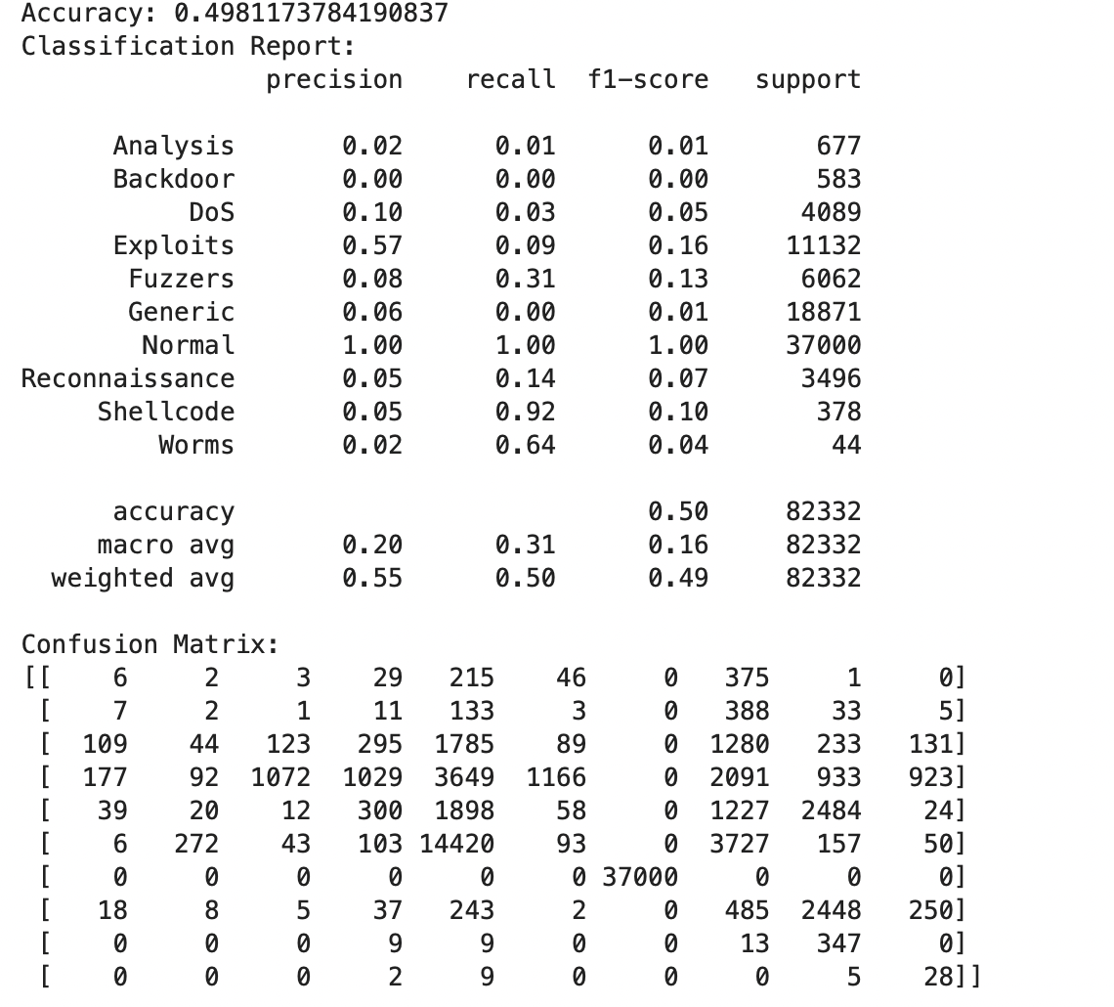

#### Classification Report (Training Clean Model)

1. **Precision, Recall, F1-score**:
   * The model performs well in detecting the "Normal" category, with a perfect score (precision, recall, F1-score all equal to 1.00), which indicates it’s very good at identifying normal traffic without mistakenly categorizing attacks as normal.
   * For attack categories, the model struggles significantly. Precision, recall, and F1-scores are very low across categories such as "Analysis," "Backdoor," "DoS," and "Exploits." For instance, "Exploits," one of the larger attack classes, has a precision of 0.57 but a recall of only 0.09, indicating that although some exploits are detected, the model misses the majority.
   * Other attack types, especially rare ones like "Worms" and "Shellcode," show extremely low F1-scores, suggesting that the model has difficulty detecting less frequent attack types.
2. **Weighted Average**:
   * The weighted average F1-score is around 0.49, meaning the model’s overall effectiveness at identifying attacks is limited. This is largely due to class imbalance, as "Normal" traffic dominates the data.

#### Confusion Matrix (Training Clean Model)

The confusion matrix further confirms that the model is overfitting to the "Normal" class:

* **Normal Class**: The model correctly identifies nearly all normal instances (37,000 out of 37,000) with minimal misclassifications.
* **Attack Misclassifications**: Most attack categories are incorrectly classified, often being confused with each other. For instance:
  + A significant number of "DoS" instances are misclassified as "Exploit" or "Fuzzer."
  + Many "Generic" instances are misclassified as "Exploit."
* **Shellcode and Worms**: The model occasionally misidentifies other attacks as "Shellcode" and "Worms," likely because these classes have very few samples, making it hard to generalize.

### Boundary Attack

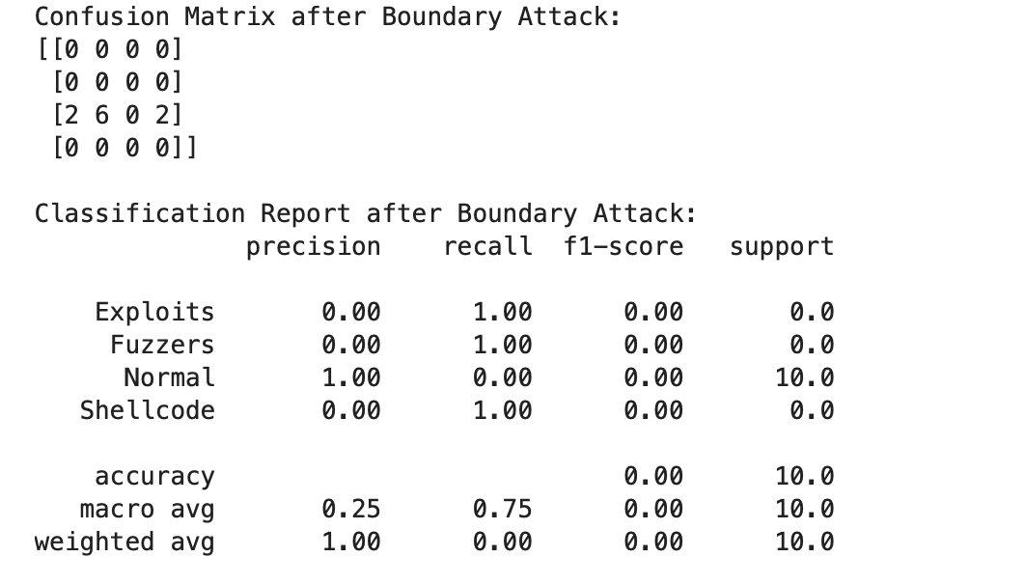

#### Classification Report After Boundary Attack

1. **Precision, Recall, F1-score**:
   * The post-attack report shows strange results, particularly with several categories showing zero support (indicating no samples for those categories were in the test set, possibly due to the attack manipulation).
   * The "Normal" category has perfect precision but zero recall, suggesting that while it can still predict normal traffic as normal, none of the normal instances in the test set were predicted correctly.
   * Attack categories like "Exploits," "Fuzzers," and "Shellcode" have recall scores of 1.00, indicating the model is identifying everything as attacks post-attack manipulation, resulting in very poor precision.
2. **Macro and Weighted Averages**:
   * The low macro and weighted averages indicate that the model’s ability to classify has been heavily compromised by the attack, essentially failing to differentiate classes.

#### Confusion Matrix After Boundary Attack

The confusion matrix after the boundary attack reveals the breakdown in the model's performance:

* **Attack Misclassifications**: The matrix primarily shows that the model is either not detecting any patterns or defaulting to misclassification across categories, as seen in the sparse non-zero entries.
* **Zeros for Normal and Majority of Attack Types**: Most of the cells are zero, indicating a collapse in the model’s classification ability.

#### Overall Insights and Conclusion

1. **Impact of Class Imbalance**:
   * The model’s initial training heavily favored the "Normal" class, leading it to perform poorly on various attack types. This suggests that the oversampling or model adjustments might need to be more sophisticated, as simple oversampling didn’t yield a balanced model.
2. **Model Sensitivity to Adversarial Attacks**:
   * The boundary attack has clearly disrupted the model's decision boundaries, rendering it ineffective. The fact that the model's classification capability essentially collapses with the boundary attack indicates a vulnerability in how it differentiates attacks from normal traffic.

### HopSkiJump Attack

#### Key Observations from the HopSkipJump Attack Classification Report

1. **Precision, Recall, and F1-Score Analysis**:
   * **"Normal" Category**: The precision for "Normal" is 1.00, but its recall is 0.00. This pattern indicates that, when the model predicts "Normal," it is always correct, but it is failing to correctly identify any actual normal instances in the data.
   * **Attack Categories (Exploits, Fuzzers, Shellcode)**: These categories have recall values of 1.00 but precision of 0.00, which suggests the model is overclassifying everything as attacks, regardless of the true label. This imbalance means that while the model detects attacks, it fails to do so accurately.
   * **F1-Score**: The F1-score is zero for all classes due to the combination of low precision and/or low recall. This score indicates that the model is essentially unable to balance precision and recall effectively for any category under the HopSkipJump attack.
2. **Macro and Weighted Averages**:
   * The **macro average** recall is high (0.75), while precision and F1-scores are very low. This discrepancy indicates that while some attack classes are detected at a high rate, their precision is so low that the model's overall classification capability is ineffective.
   * The **weighted average precision and F1-scores** are both 0.00, meaning the model’s classification attempts are practically useless in this scenario due to the overwhelming misclassification of normal instances as attacks.

#### Comparison with Boundary Attack

Both the HopSkipJump and boundary attacks produce a similar outcome: the model is heavily disrupted and fails to correctly classify any of the test samples. However, there are subtle differences:

1. **Misclassification Pattern**:
   * In both attacks, the model fails to detect the "Normal" category correctly, with a recall of 0.00 for "Normal" in each case. This similarity suggests that both attacks manipulate the decision boundary in a way that prevents the model from recognizing normal instances.
   * **HopSkipJump Impact on Recall**: Unlike the boundary attack, which may create sparse, random misclassifications in attack classes, HopSkipJump appears to force the model to detect attack categories without regard to precision. This overclassifies almost all instances as attacks, highlighting an aggressive manipulation of the decision boundary toward attack classes.
2. **Structural Weaknesses Exposed**:
   * The **boundary attack** initially revealed the model's vulnerability to minor decision boundary adjustments, leading to random misclassifications.
   * **HopSkipJump** amplifies this by creating an adversarial situation where the model’s decision function is even more heavily skewed, pushing all instances toward attacks. This points to an underlying model fragility where the decision boundaries between attack and normal classes are too easily manipulated.
3. **Implications for Model Robustness**:
   * Both attacks show that the model's decision boundaries are not robust, especially in distinguishing between "Normal" and attack classes. The model heavily relies on clear separations between these classes, which these adversarial attacks exploit.
   * The fact that both attacks yield such drastic misclassification patterns suggests that this model is highly sensitive to boundary manipulations. It likely lacks sufficient feature robustness and may benefit from techniques designed to withstand adversarial perturbations, such as adversarial training or more complex ensemble methods.

#### Summary and Recommendations

The HopSkipJump and boundary attacks both expose a significant weakness in the model’s ability to handle adversarial inputs:

* **Both attacks cause the model to fail entirely** at distinguishing normal traffic from attacks, though HopSkipJump is slightly more aggressive in biasing predictions toward attack classes.
* This vulnerability suggests that the model lacks **robust decision boundaries** that separate classes effectively.

#### Next Steps to Address Vulnerabilities

1. **Adversarial Training**: Incorporate adversarial examples into the training set to help the model learn more resilient decision boundaries.
2. **Model Complexity**: Consider using more sophisticated model architectures or ensembles that may offer more stable boundaries between normal and attack classes.
3. **Regularization and Feature Engineering**: Enhanced feature engineering, along with regularization, might improve the model’s ability to generalize beyond specific decision boundaries that can easily be attacked.
4. **Adversarial Defense Techniques**: Employ adversarial defense methods such as defensive distillation or gradient masking, which are designed to make models more robust to attacks like HopSkipJump and boundary manipulation.

## Model : XGBoost

### Clean Data

#### Initial Evaluation (Clean Data)

* **Accuracy**: 74.03% – The model performs moderately well on the clean data, capturing significant patterns in certain classes while struggling with others.
* **Class-Specific Observations**:
  + **Normal** class has perfect precision, recall, and f1-score (1.00 across the board), which indicates the model is exceptionally good at identifying "Normal" instances.
  + **Generic** has high precision (1.00) but moderate recall (0.60), meaning the model often correctly classifies it but misses some instances.
  + **Reconnaissance** and **Fuzzers** show a solid balance of precision and recall, indicating reasonable performance on these types.
  + However, for classes like **Analysis** and **Backdoor**, the precision and recall are very low, suggesting the model struggles to distinguish these attack types from others.
* **Macro and Weighted Averages**:
  + The macro average for precision, recall, and f1-score is relatively low compared to the weighted averages. This indicates that the model performs better on high-support classes (like **Normal** and **Generic**) than on low-support ones (like **Worms** and **Shellcode**).

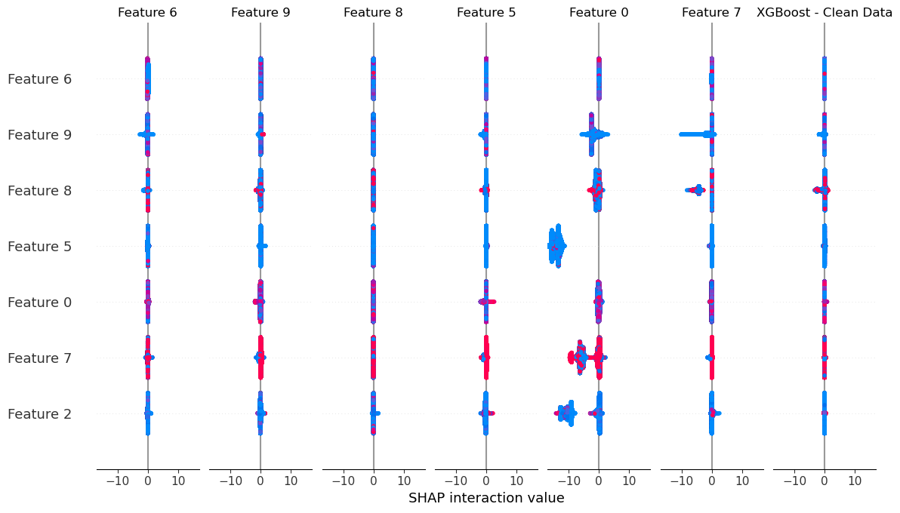

### Boundary Attack

#### Boundary Attack Evaluation

* **Accuracy**: 0% – The model is unable to correctly classify any adversarially perturbed instances.
* **Class-Specific Observations**:
  + **Exploits** and **Fuzzers** appear with full recall in the adversarial context, but this is misleading. The adversarial samples generated for these classes are misclassified, leading to incorrect predictions despite achieving "100% recall".
  + **Normal** class has perfect precision but zero recall, indicating that no normal instances were correctly identified as such after the attack.
* **Summary**:
  + The Boundary Attack completely disrupts the model’s ability to accurately classify. The attack’s effectiveness reveals the model’s significant vulnerability to adversarial perturbations, especially for high-support classes like **Normal**.

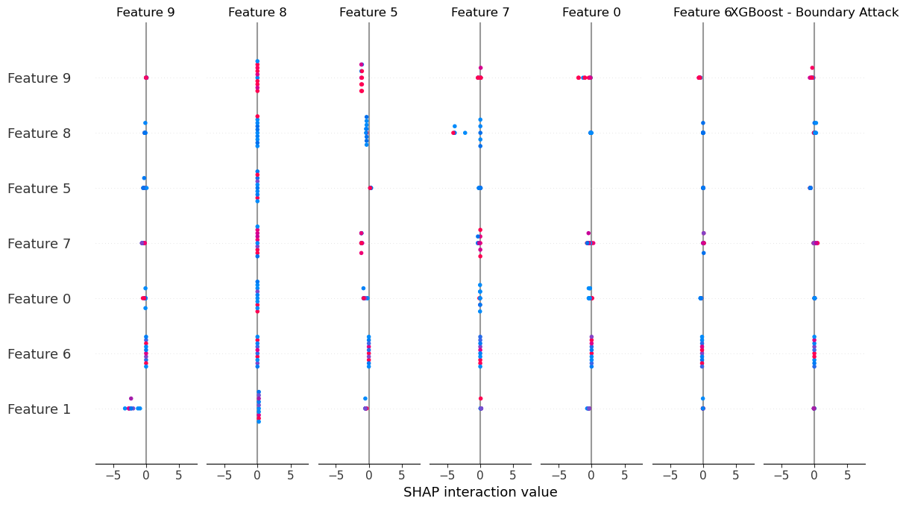

### HopSkiJump Attack

#### HopSkipJump Attack Evaluation

* **Accuracy**: 0% – Similar to the Boundary Attack, the model fails to correctly classify any adversarially modified instances.
* **Class-Specific Observations**:
  + The model’s response to the **HopSkipJump Attack** is particularly concerning, as all predictions for **Normal**are misclassified. Like the Boundary Attack, classes such as **DoS**, **Exploits**, and **Fuzzers** are misclassified, with the model displaying artificially high recall in these categories.
  + This shows a failure to detect true adversarial instances for all attack classes.

#### Summary and Insights

* **Strengths**:
  + On clean data, the model performs relatively well for high-support classes, particularly **Normal** and **Generic**.
* **Weaknesses**:
  + There’s a clear lack of robustness in handling low-support attack categories, and the model is highly susceptible to adversarial attacks like Boundary and HopSkipJump.
  + Both attacks manage to exploit the model’s vulnerabilities, especially in classes with high support, leading to complete misclassification of adversarial samples.
* **Potential Improvements**:
  + Consider incorporating **adversarial training** or using **robust models** that are specifically designed to withstand adversarial perturbations.
  + Additionally, techniques like **ensemble methods** or **defensive distillation** could improve resistance to adversarial attacks.

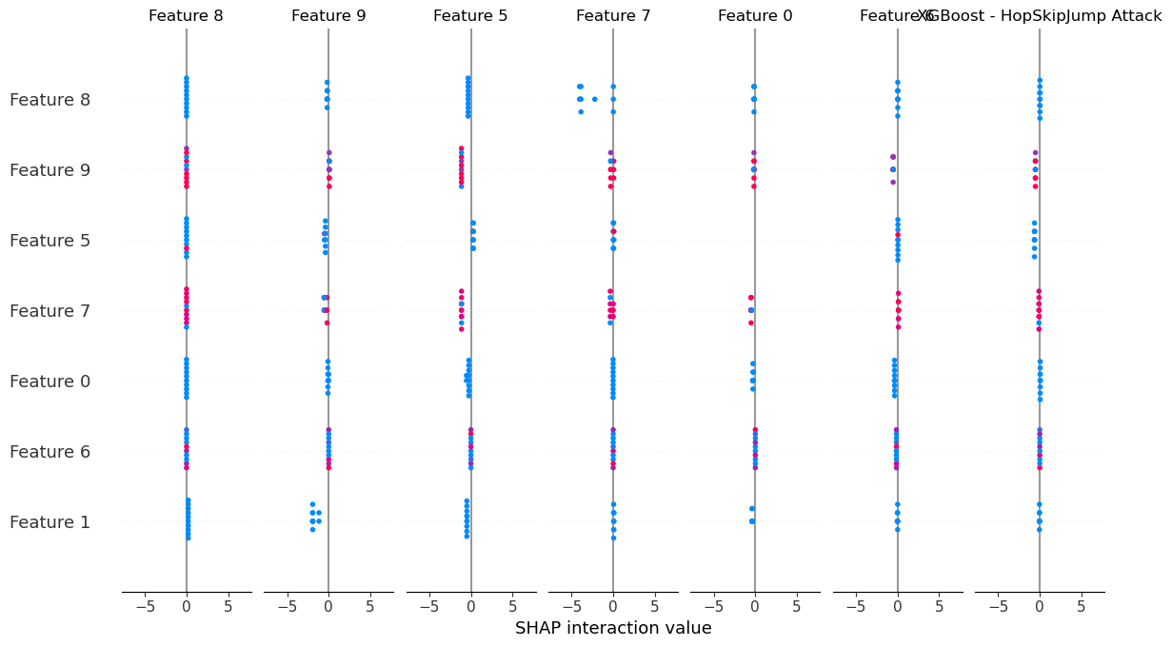

## Model : NN

### Clean Data

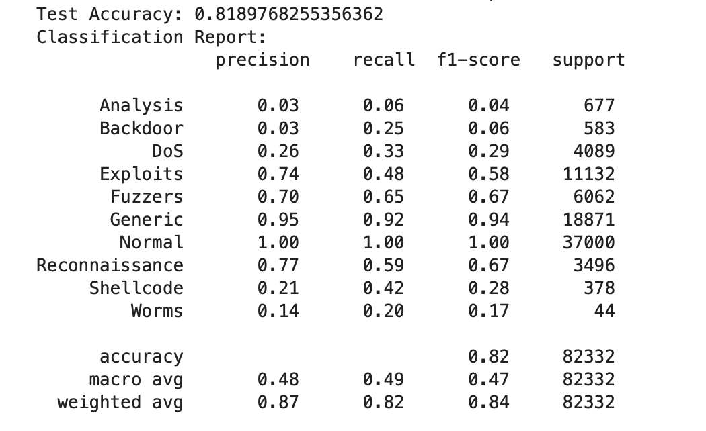

#### Clean Data Analysis

* **Test Accuracy**: 0.82 (82%)
* **Classification Report Insights**:
  + **Normal**: Highest performance, with nearly perfect precision, recall, and F1-score, suggesting that the model is very confident in detecting normal traffic.
  + **Generic**: High performance (F1-score 0.94), reflecting strong model confidence in this category as well.
  + **Exploits and Fuzzers**: Moderate performance, with F1-scores of 0.58 and 0.67 respectively.
  + **Low-Performance Classes**:
    - Classes like Analysis, Backdoor, Shellcode, and Worms show low precision, recall, and F1-scores. These classes have sparse support, which likely impacts the model's learning ability, leading to low recognition of these attacks.

**Summary**: The model performs well on "Normal" and common attack classes but struggles with rarer and subtler attacks.

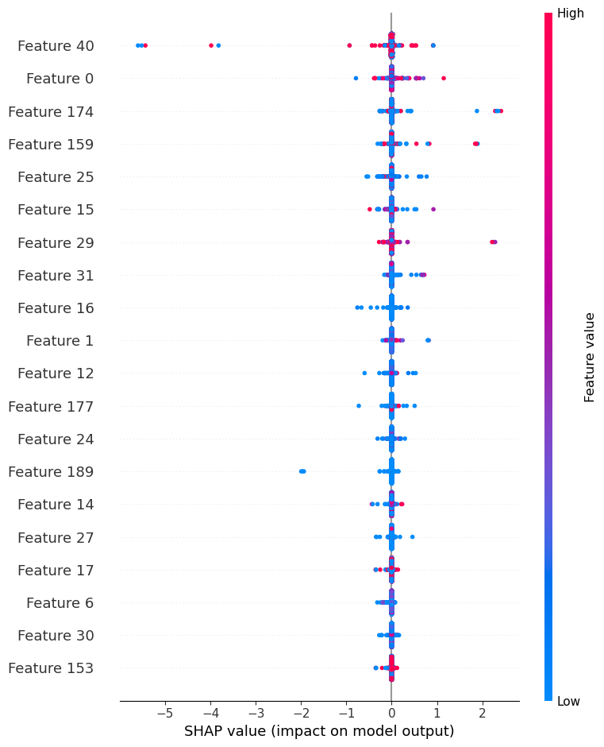

### FGSM Attack

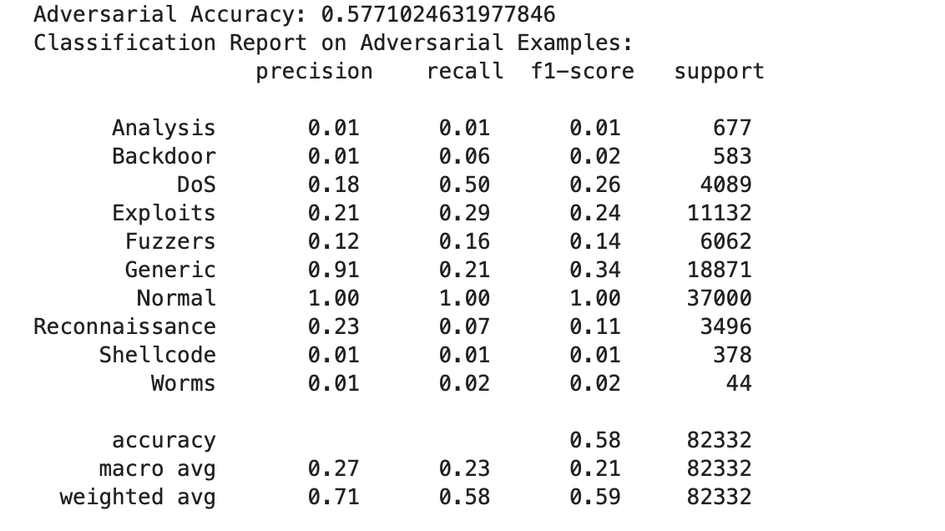

#### FGSM Adversarial Attack

* **Adversarial Accuracy**: 0.58 (58%)
* **Classification Report Insights**:
  + The accuracy drops significantly, highlighting the model's vulnerability to FGSM.
  + **Normal**: The recall remains at 1.00, indicating the model is still able to identify "Normal" samples with complete recall. However, precision and recall for most attack classes decrease drastically.
  + **Generic**: Drops in recall to 0.21, suggesting a high rate of misclassification under FGSM attack.
  + **DoS**: Maintains moderate performance with an F1-score of 0.26, but shows a significant drop from the clean data results.
  + **Most Other Classes**: Precision and recall are particularly low (e.g., Analysis with an F1-score of 0.01 and Backdoor with 0.02), indicating that FGSM effectively disrupts the model's ability to detect these attacks.

**Summary**: FGSM introduces significant noise that misleads the model, causing it to struggle with the majority of attack classes while still recognizing normal traffic well.

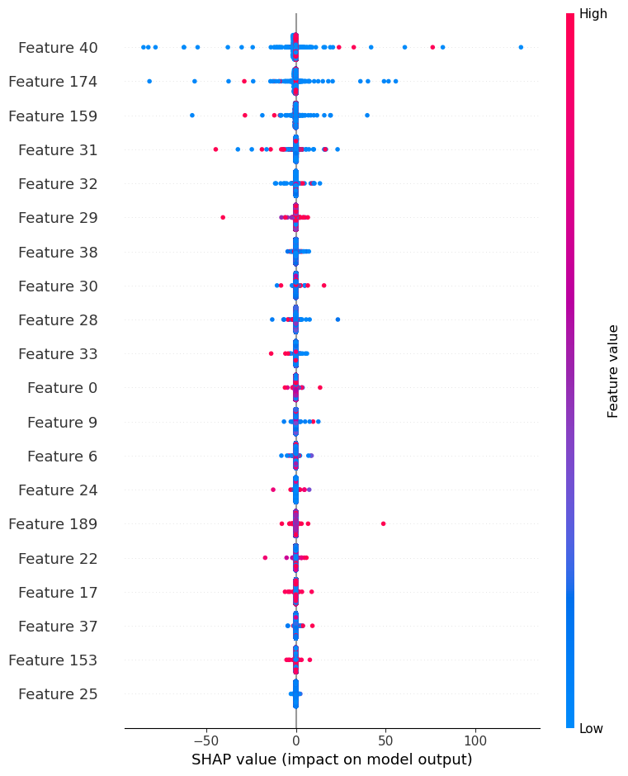

### PGD Attack

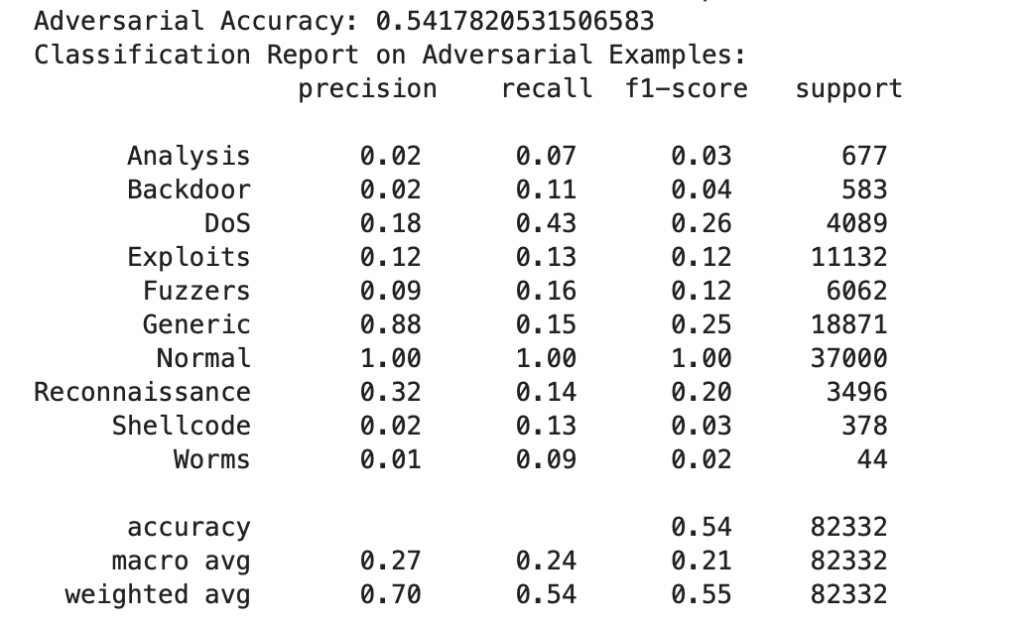

#### PGD Adversarial Attack

* **Adversarial Accuracy**: 0.54 (54%)
* **Classification Report Insights**:
  + PGD has a stronger degrading effect compared to FGSM, reducing the model's accuracy further.
  + **Normal**: Maintains a recall of 1.00, similar to FGSM, which suggests resilience for "Normal" classification, although other metrics suffer.
  + **Generic**: Severely impacted, with an F1-score dropping to 0.25.
  + **DoS and Reconnaissance**: Show some level of detection with F1-scores of 0.26 and 0.20, respectively, but still reflect a drop from clean data.
  + **Backdoor, Analysis, and Worms**: Suffer substantially, with F1-scores close to zero, indicating that the model is highly vulnerable to these attacks under PGD.

**Summary**: PGD is more effective than FGSM in disrupting model performance, especially in recognizing non-normal traffic. PGD’s iterative nature likely makes it more challenging for the model to differentiate between "Normal" and attack samples.

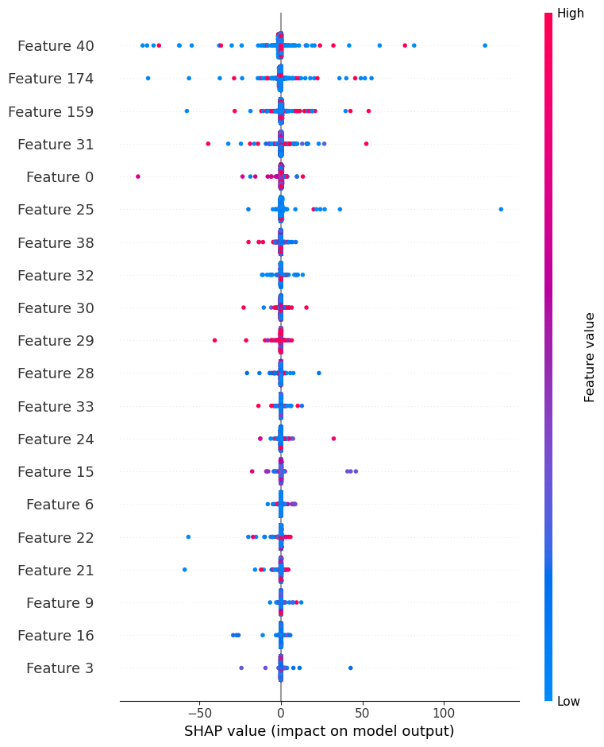

### Carlini&Wagner Attack

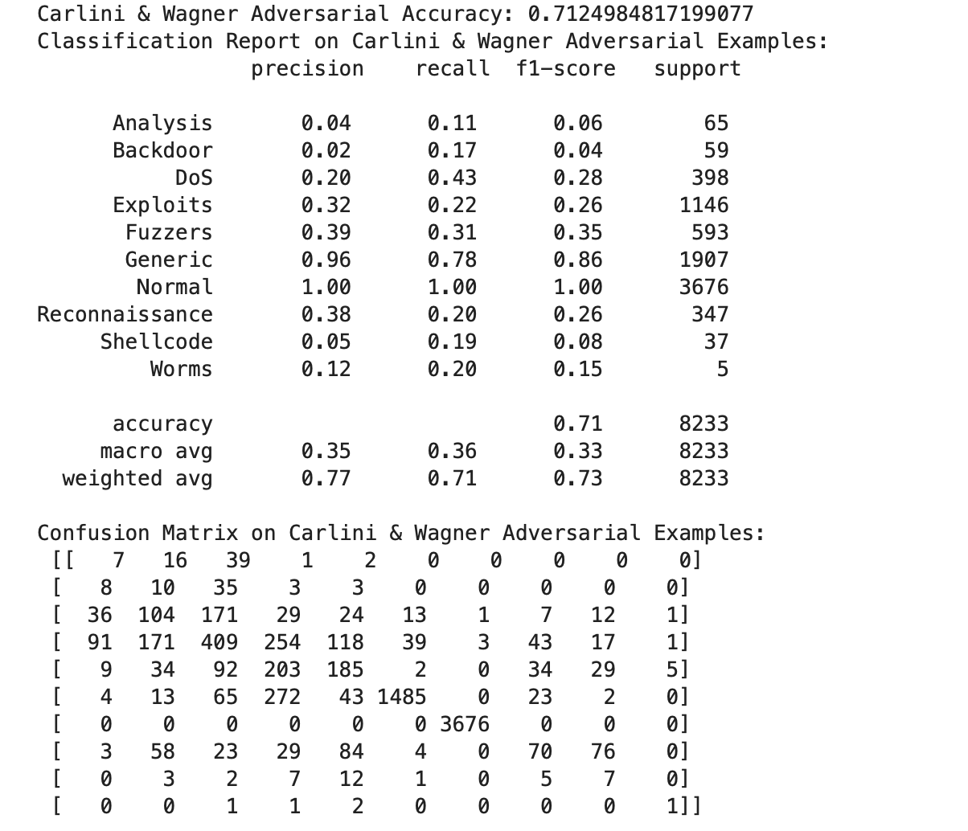

#### Carlini & Wagner (C&W) Attack

* **Adversarial Accuracy**: 0.71 (71%)
* **Classification Report Insights**:
  + C&W is less impactful compared to FGSM and PGD, resulting in a higher accuracy (0.71) even under adversarial conditions.
  + **Normal**: Recall remains at 1.00, showing strong resilience.
  + **Generic**: While performance drops, it is still relatively high with an F1-score of 0.86, showing that the model can still detect generic attacks better than with FGSM or PGD.
  + **Exploits and Fuzzers**: Moderately affected, with F1-scores of 0.26 and 0.35, respectively, indicating some resilience.
  + **Other Classes**: Classes like DoS, Reconnaissance, and Shellcode suffer in F1-scores but still retain some level of detection capability compared to FGSM and PGD.

**Summary**: C&W is less disruptive compared to FGSM and PGD, with the model showing stronger robustness across multiple classes, especially Normal, Generic, and some common attack types.

### **Overall Comparison of Attack Impact**

1. **Effectiveness of Attacks**:
   * **Most Effective**: PGD is the most disruptive, with the largest drop in accuracy and widespread degradation across classes.
   * **Moderate Effectiveness**: FGSM also significantly impacts the model but to a lesser degree than PGD.
   * **Least Effective**: C&W shows the least impact, with the model retaining higher performance on "Normal" and high-support classes.
2. **Class-Specific Vulnerabilities**:
   * All attacks impact rarer classes (Analysis, Backdoor, Shellcode, Worms) heavily, reflecting the model’s limited robustness for these less frequent categories.
   * "Normal" traffic is consistently detected with high recall across attacks, likely due to its prominence in training data.
3. **Implications for Model Improvement**:
   * Enhancing the model's resilience to adversarial attacks on classes with limited support could involve techniques such as adversarial training or data augmentation.
   * Exploring robust defense mechanisms, especially for iterative attacks like PGD, may improve the model’s stability across various adversarial strategies.

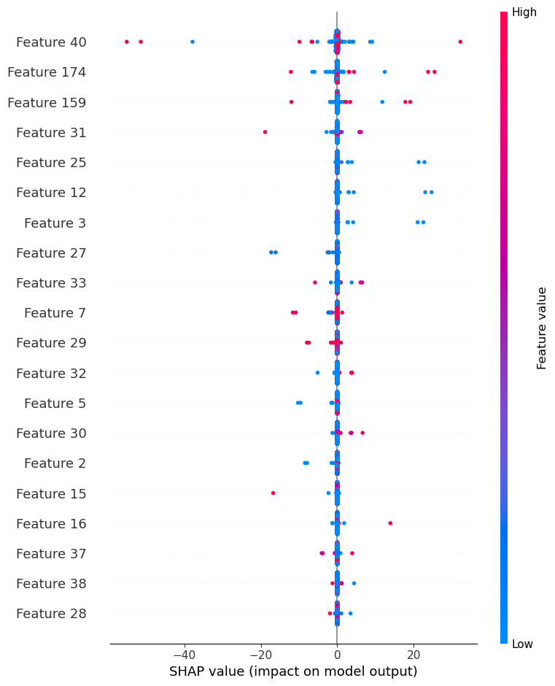

## Model : MLP

### Clean Data

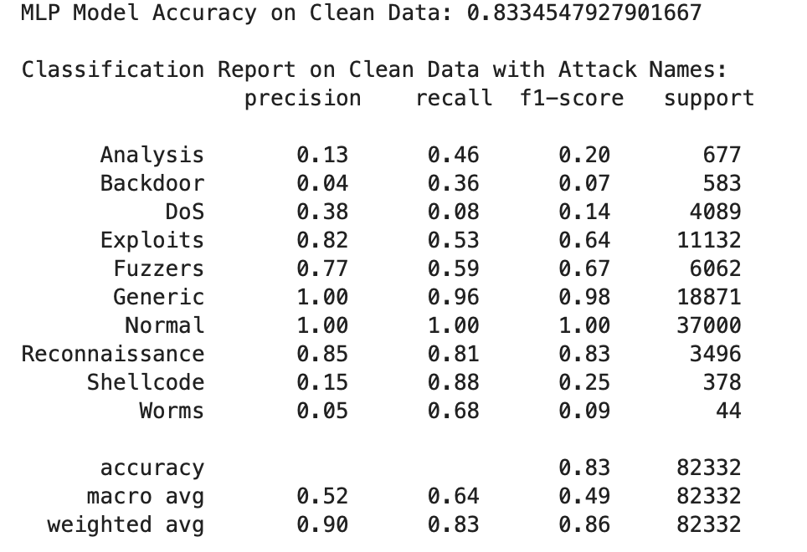

#### Performance on Clean Data

#### Key Metrics

* **Accuracy**: 83.3%
* **Macro Average**:
  + Precision: 0.52
  + Recall: 0.64
  + F1-Score: 0.49
* **Weighted Average**:
  + Precision: 0.90
  + Recall: 0.83
  + F1-Score: 0.86

#### Detailed Analysis

* **High Accuracy and Weighted Averages**: The model performs well on clean data, with strong accuracy and high weighted averages across metrics. The high accuracy is driven by excellent performance in classes with substantial support, especially "Normal" and "Generic."
* **Class-Level Insights**:
  + **"Normal" and "Generic" Classes**: The model achieves 1.00 recall and precision on "Normal," and nearly perfect recall and precision on "Generic" (0.96 and 1.00, respectively). These results greatly boost the overall accuracy.
  + **Moderate Performance on Reconnaissance and Exploits**: For "Reconnaissance" (f1-score of 0.83) and "Exploits" (f1-score of 0.64), the model performs decently, capturing a large portion of these instances.
  + **Poor Detection of Minor Attack Types**: Classes like "Worms," "Backdoor," and "Shellcode" have low precision and recall, with zero to minimal detection in some cases. For example, "Worms" has a 0.05 recall, which translates to missed attack detection, limiting the model’s robustness against varied attack types.

#### Conclusion on Clean Data

The MLP model is accurate on clean data, benefiting from strong recall on highly represented classes but struggling with low-recall and low-support attack classes.

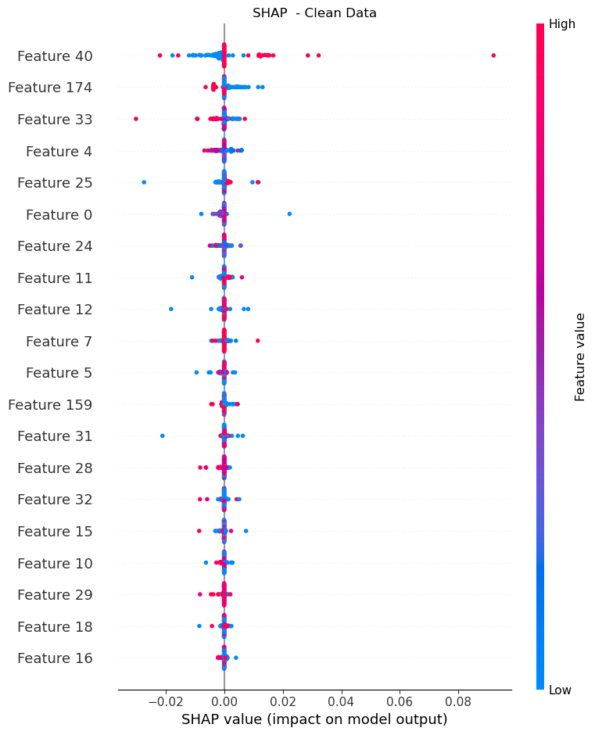

### FGSM Attack

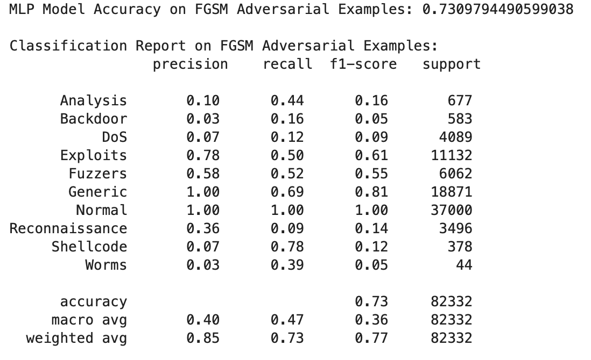

#### Performance on FGSM Adversarial Examples

#### Key Metrics

* **Accuracy**: 73.1%
* **Macro Average**:
  + Precision: 0.40
  + Recall: 0.47
  + F1-Score: 0.36
* **Weighted Average**:
  + Precision: 0.85
  + Recall: 0.73
  + F1-Score: 0.77

#### Detailed Analysis

* **Accuracy Drop**: The accuracy drops significantly from 83.3% to 73.1%, and the macro averages for precision, recall, and f1-score are much lower than on clean data, indicating the FGSM attack's adverse effect.
* **Class-Level Analysis**:
  + **"Normal" and "Generic" Classes**: The "Normal" class maintains perfect recall, while the "Generic" class drops in recall from 0.96 to 0.69. This indicates a noticeable impact on the model’s classification of the "Generic" class.
  + **Notable Vulnerabilities**: Classes such as "Backdoor," "Reconnaissance," and "Shellcode" experience a significant drop in recall and f1-scores. For example, "Backdoor" drops to a recall of 0.16 and an f1-score of 0.05, showing poor resilience against adversarial examples.
  + **Impaired Detection Across Attack Types**: Most attack types, including "DoS" and "Exploits," show reduced recall and f1-scores, suggesting that the FGSM adversarial perturbations severely disrupt attack detection.

#### Conclusion on FGSM Data

The MLP model’s performance deteriorates under FGSM adversarial examples, retaining accuracy mainly on the "Normal" class, while other classes, especially less common attacks, suffer in recall and detection accuracy.

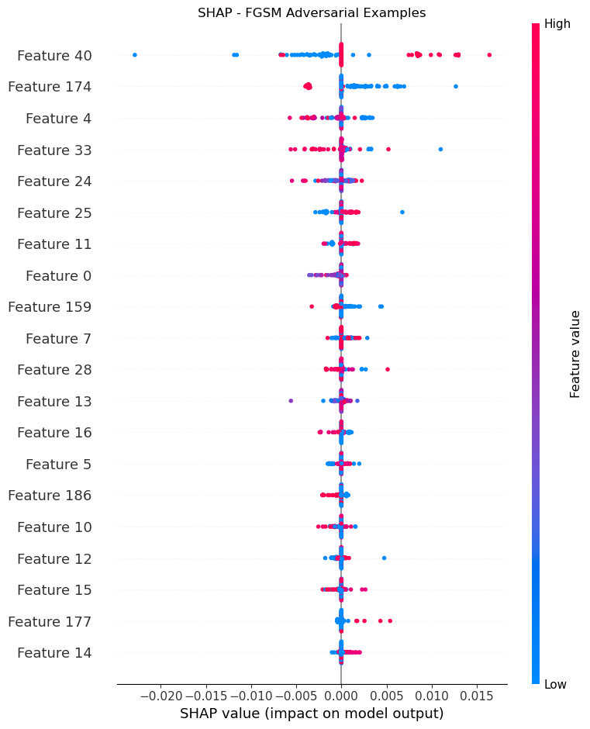

### PGD Attack

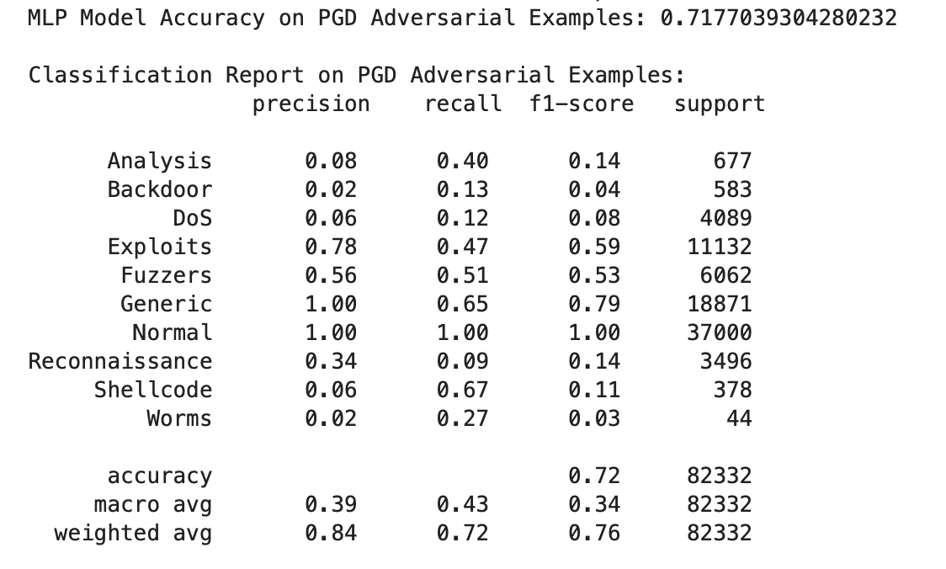

#### Performance on PGD Adversarial Examples

#### Key Metrics

* **Accuracy**: 71.8%
* **Macro Average**:
  + Precision: 0.39
  + Recall: 0.43
  + F1-Score: 0.34
* **Weighted Average**:
  + Precision: 0.84
  + Recall: 0.72
  + F1-Score: 0.76

#### Detailed Analysis

* **Further Accuracy Reduction**: Accuracy drops to 71.8%, slightly lower than FGSM, indicating a stronger effect of PGD on the model’s performance.
* **Class-Level Analysis**:
  + **"Normal" Class**: The recall remains high for the "Normal" class, helping sustain the overall accuracy, but some degradation is visible in other high-support classes.
  + **Continued Decline in Attack Detection**: Attack types such as "Backdoor" (recall of 0.13), "DoS" (recall of 0.12), and "Reconnaissance" (recall of 0.09) display lower recall and f1-scores than with FGSM. This suggests that PGD adversarial perturbations may be more effective at confusing the model on certain attack classes.
  + **Shellcode and Worms**: These classes show very low recall, indicating that the model almost entirely fails to detect these adversarial examples. For example, "Shellcode" maintains a 0.67 recall but suffers from a low f1-score of 0.11, indicating a hit-or-miss detection pattern.

#### Conclusion on PGD Data

The model’s accuracy and detection ability continue to decline with PGD adversarial examples. Classes that were already difficult to detect (like "Backdoor" and "Shellcode") worsen, showing that PGD effectively reduces the MLP model's ability to generalize.

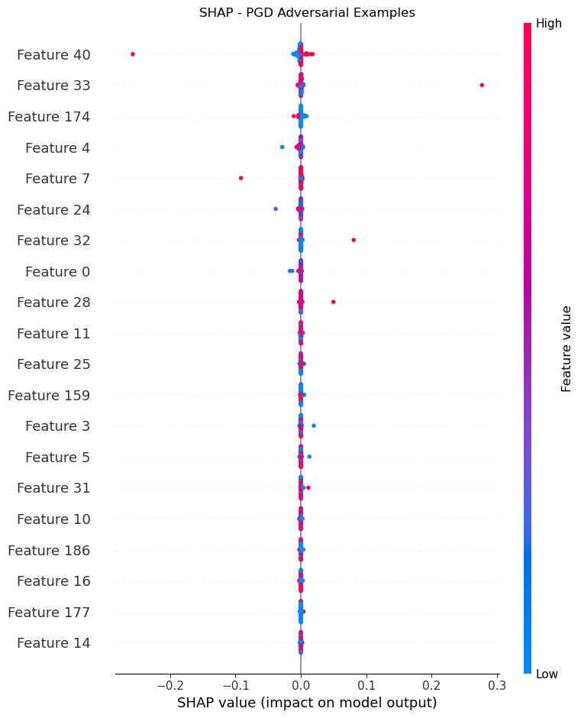

### Carlini&Wagner Attack

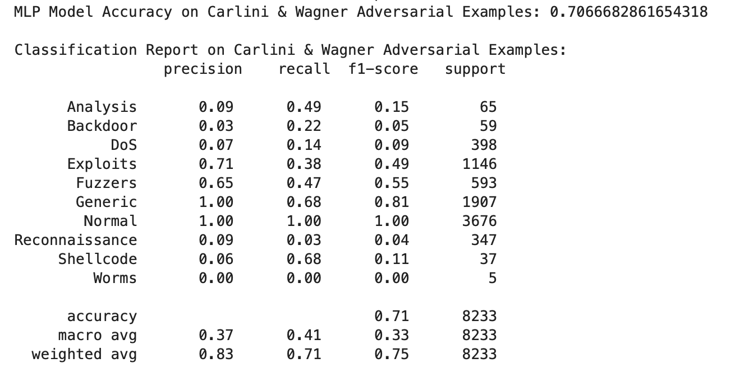

#### Performance on Carlini & Wagner (CW) Adversarial Examples

#### Key Metrics

* **Accuracy**: 70.7%
* **Macro Average**:
  + Precision: 0.37
  + Recall: 0.41
  + F1-Score: 0.33
* **Weighted Average**:
  + Precision: 0.83
  + Recall: 0.71
  + F1-Score: 0.75

#### Detailed Analysis

* **Significant Accuracy Drop**: Accuracy reaches its lowest at 70.7%, and macro averages further decrease, indicating that the Carlini & Wagner attack is highly effective at compromising the model’s general performance.
* **Class-Level Analysis**:
  + **Reduced "Generic" and "Normal" Class Performance**: The "Generic" class recall drops further to 0.68, and while the "Normal" class maintains a perfect recall, this balance does not compensate for the severe losses in other classes.
  + **Vulnerability to CW in Minor Classes**: Classes such as "Analysis" and "Backdoor" have low f1-scores (0.15 and 0.05, respectively), with many classes almost entirely undetected. For instance, "Worms" has a recall of 0.00, suggesting a near-total failure in detection.
  + **Variability in Detection of "Shellcode"**: While "Shellcode" recall remains high at 0.68, its f1-score is extremely low, showing that predictions in this category may be inconsistent and imprecise.

#### Conclusion on CW Data

The CW adversarial attack most effectively compromises the model's performance, particularly impacting the detection of lesser-represented attack types like "Backdoor" and "Reconnaissance," where recall drops to near-zero. CW also affects the larger classes, albeit to a lesser extent, with notable declines in precision and recall for "Generic."

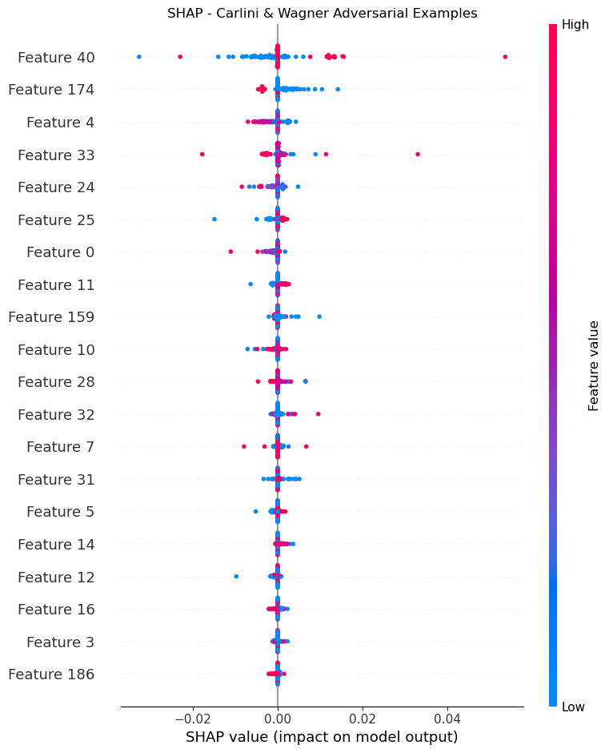

#### 

#### 

#### 

#### 

#### 

#### 

#### 

#### Summary and Comparison

| **Data Type** | **Accuracy** | **Macro Precision** | **Macro Recall** | **Macro F1-Score** | **Weighted Precision** | **Weighted Recall** | **Weighted F1-Score** |
| --- | --- | --- | --- | --- | --- | --- | --- |
| Clean Test Data | 83.3% | 0.52 | 0.64 | 0.49 | 0.90 | 0.83 | 0.86 |
| FGSM Adversarial | 73.1% | 0.40 | 0.47 | 0.36 | 0.85 | 0.73 | 0.77 |
| PGD Adversarial | 71.8% | 0.39 | 0.43 | 0.34 | 0.84 | 0.72 | 0.76 |
| Carlini & Wagner (CW) | 70.7% | 0.37 | 0.41 | 0.33 | 0.83 | 0.71 | 0.75 |

#### Comparative Summary

* **Overall Impact of Adversarial Attacks**: The model's accuracy and macro averages decrease consistently across FGSM, PGD, and CW adversarial attacks, with Carlini & Wagner having the most severe impact. The significant drop from 83.3% accuracy on clean data to 70.7% on CW examples highlights the model’s vulnerability.
* **Class-Specific Impact**:
  + **"Normal" Class**: Consistently high recall across all conditions sustains the model’s overall accuracy.
  + **Attack Classes**: Minor attack classes ("Backdoor," "Worms," "Reconnaissance") show substantial drops in recall and f1-scores, with near-zero recall on CW examples.
  + **Robustness of "Generic" Class**: Despite declines, the "Generic" class maintains a relatively high recall, suggesting the model may better generalize on this type.
* **Macro vs. Weighted Averages**: The disparity between macro and weighted averages highlights the model’s bias toward well-represented classes, particularly "Normal" and "Generic." The macro averages reveal the challenges in detecting various attacks, while weighted averages reflect the model’s overall tendency to classify more common classes accurately.

In conclusion, while the MLP model performs reasonably on clean data, adversarial examples, especially CW, significantly compromise its robustness, with declining performance on most attack classes and high dependency on accurately classifying "Normal" and "Generic" instances. Further adversarial training or alternative architectures may be needed to enhance resilience against these adversarial attacks.

## Model : CNN

### Clean Data

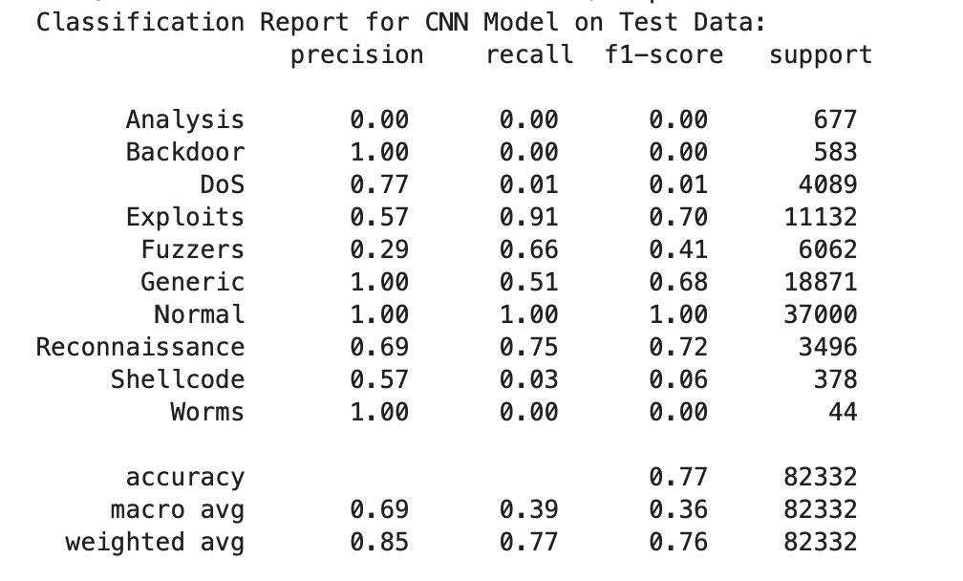

#### **Clean Test Data**:

* **Accuracy**: 77%
* **High Performers**: The model performs very well on the Normal class (1.00 precision and recall), indicating it is particularly adept at detecting normal traffic.
* **Low Performers**: Classes like Analysis, Backdoor, DoS, and Shellcode have very low recall and precision, indicating these attack types are challenging for the model to classify correctly.
* **Overall**: The weighted average F1-score is 0.76, which indicates good performance overall, but some classes are significantly misclassified.

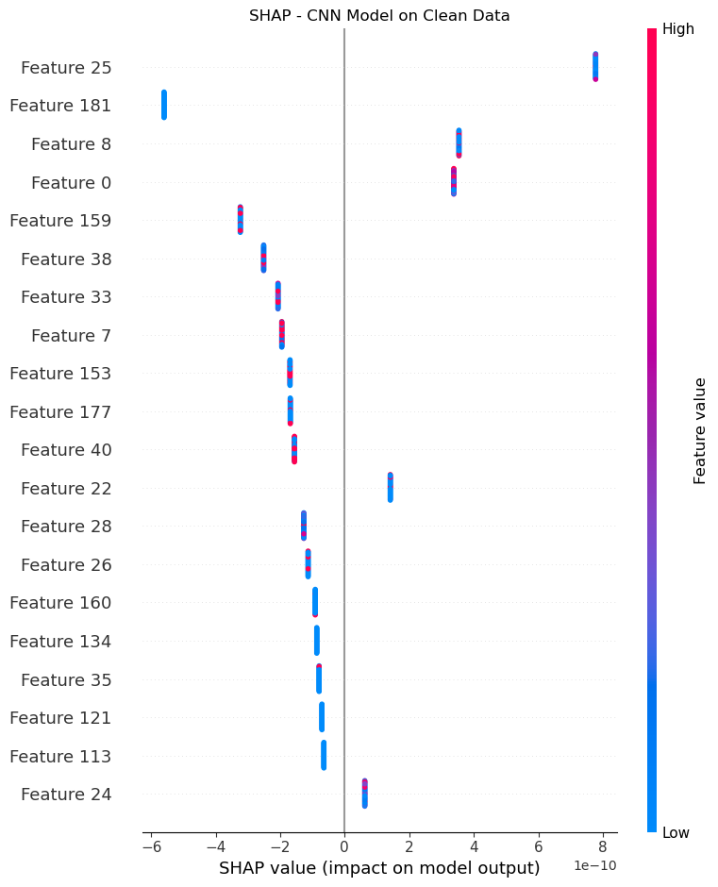

### FGSM Attack

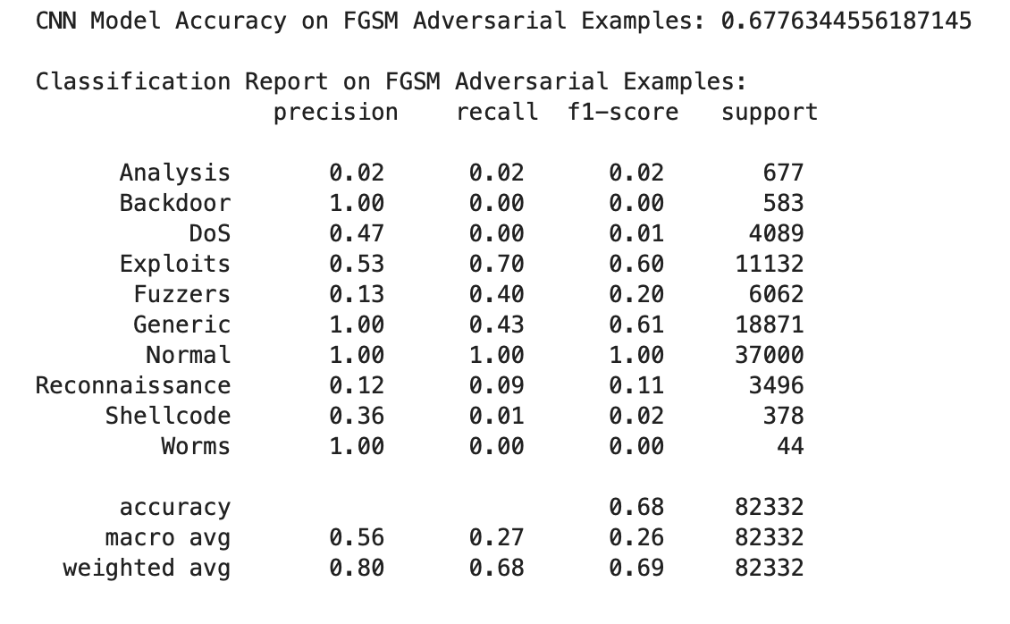

#### **FGSM Adversarial Examples**:

* **Accuracy**: 67.7%
* **Performance Drop**: The overall accuracy drops by nearly 10%, highlighting the model's vulnerability to FGSM adversarial examples.
* **Notable Class Impact**: Precision and recall for classes such as DoS and Shellcode are notably lower compared to clean data, with F1-scores dropping to near zero. Generic and Normal classes still show good performance, though Generic sees reduced precision (1.00 to 1.00) and recall (0.51 to 0.43).
* **Overall**: The weighted average F1-score decreases slightly, showing that FGSM adversarial attacks reduce the model's robustness, especially for less common attack classes.

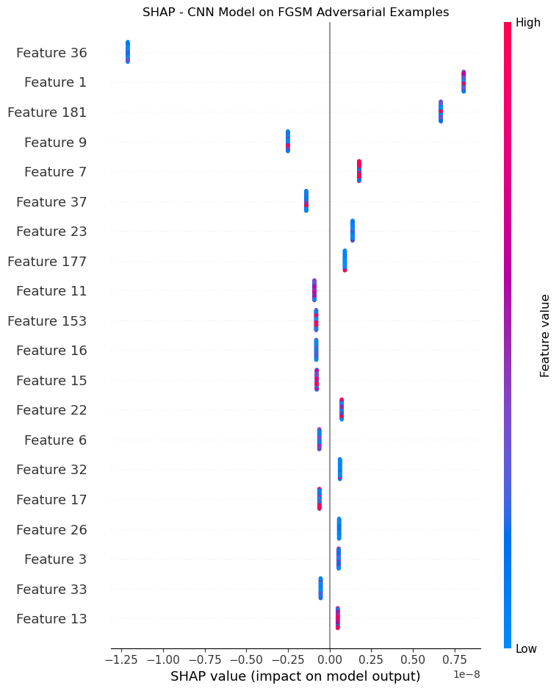

### PGD Attack

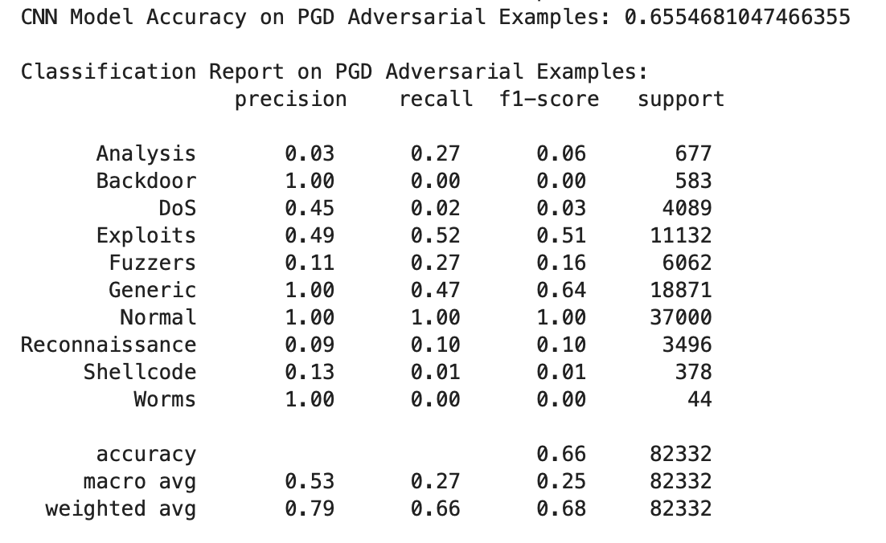

#### **PGD Adversarial Examples**:

* **Accuracy**: 65.5%
* **Further Performance Decline**: The model accuracy drops further with PGD attacks, reflecting the severity of this type of adversarial attack.
* **Significant Class-Level Impact**: Classes like Analysis, DoS, and Shellcode see major drops in recall, making the model practically ineffective at identifying them in PGD scenarios. Normal and Generic classes continue to perform well but still see reduced metrics compared to the clean test set.
* **Overall**: The macro and weighted averages drop, indicating the model's susceptibility to PGD perturbations and highlighting the need for adversarial robustness measures.

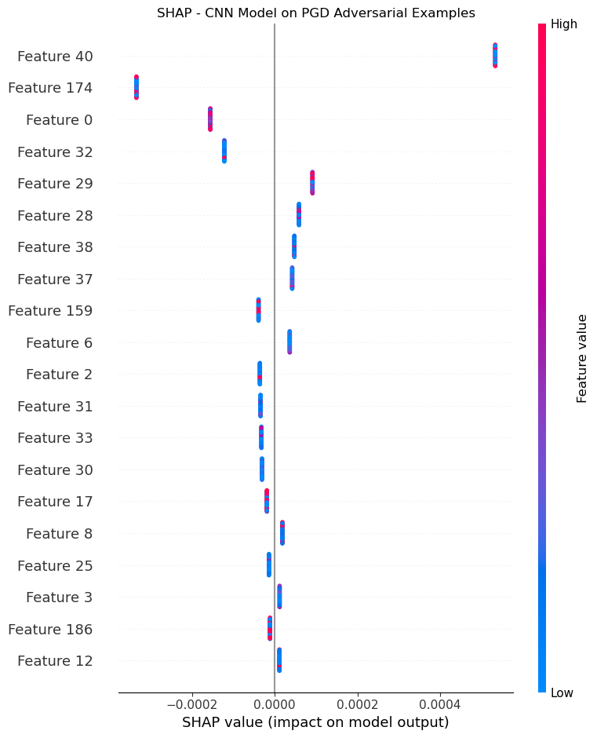

### Carlini&Wagner Attack

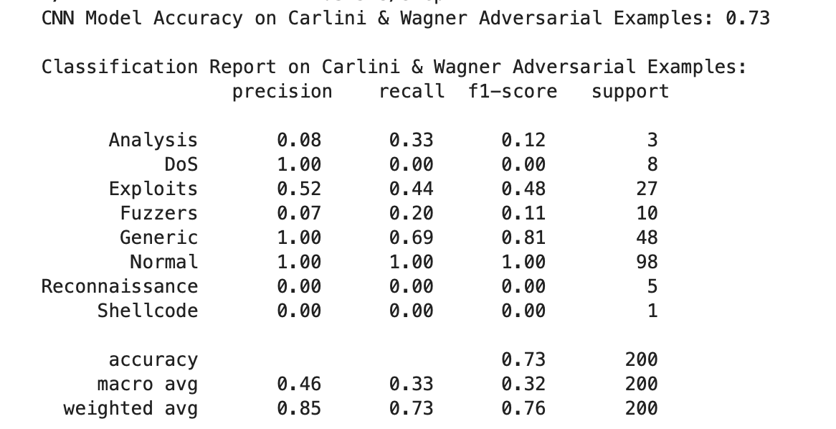

#### **Carlini & Wagner (C&W) Adversarial Examples**:

* + **Accuracy**: 73%
  + **Accuracy Impact**: The accuracy of the model is slightly higher compared to FGSM and PGD attacks but still below the clean data accuracy.
  + **Selective Vulnerability**: The model struggles with some classes (DoS, Reconnaissance, and Shellcode), with either no recall or very low F1-scores, but maintains high performance on Normal and Generic classes.
  + **Overall**: The macro average F1-score is low, indicating poor performance across most classes, though the weighted average F1-score is relatively higher due to the dominance of well-performing classes like Normal.

#### Comparative Observations and Insights

1. **Model Robustness on Clean vs. Adversarial Data**:
   * The model shows a clear drop in accuracy and F1-scores across all classes when tested on adversarial data.
   * Normal traffic (Normal class) remains consistently high-performing, suggesting the model’s general focus on identifying non-attack data.
2. **Class-Specific Vulnerabilities**:
   * Classes like Analysis, DoS, Backdoor, and Shellcode have low precision and recall, especially on adversarial examples, indicating the model's difficulty in differentiating these attacks from others or from normal traffic.
   * Some attack classes, especially DoS and Backdoor, show near-zero recall on adversarial examples, particularly on FGSM and PGD, suggesting these classes are particularly vulnerable to misclassification.
3. **Adversarial Attack Severity**:
   * **PGD** adversarial examples show the greatest impact on model accuracy (65.5%), followed by **FGSM**(67.7%) and **C&W** (73%).
   * The results indicate that PGD is particularly effective at decreasing model performance, suggesting that it produces perturbations that are more challenging for the model to handle.
4. **Macro vs. Weighted Averages**:
   * The macro averages (especially for F1-score) are significantly lower than the weighted averages, highlighting a disparity in model performance across classes.
   * High weighted averages suggest that the model performs well on more frequent classes (Normal and Generic) but struggles with less common ones, especially under adversarial conditions.

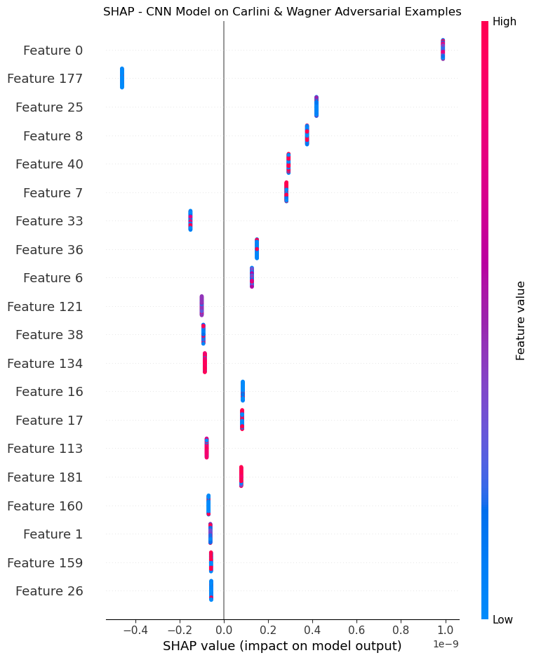

# **NSL_KDD DATASET**

## Model : RandomForest

### Clean Data

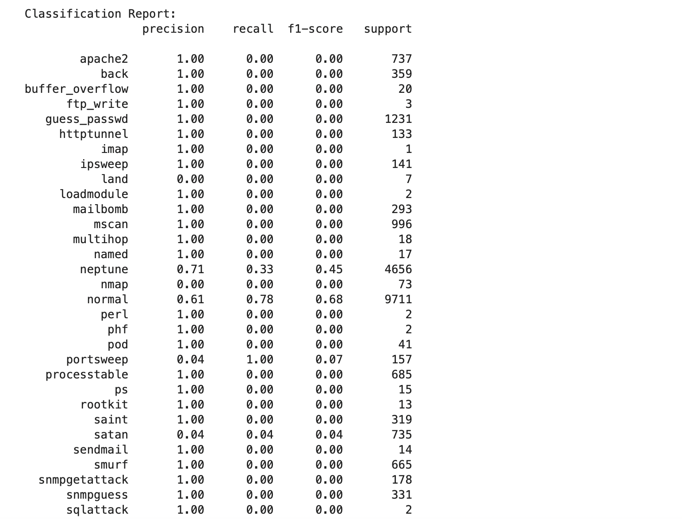

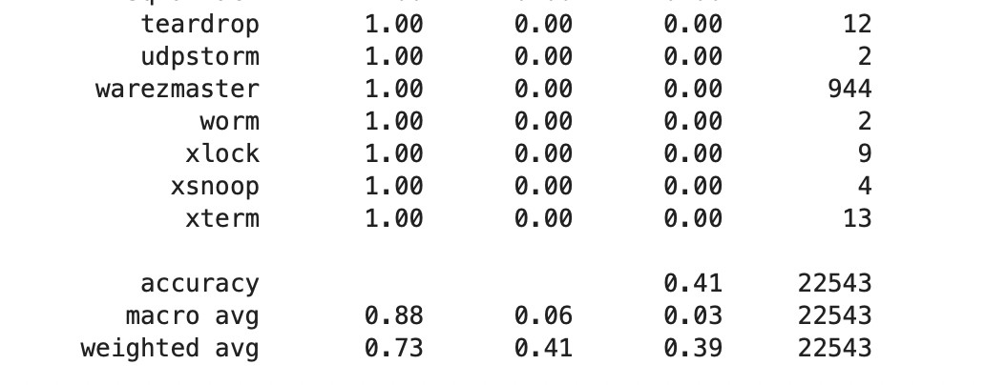

#### Original Test Data Performance

#### Key Observations:

* **Overall Accuracy**: 41% accuracy on the NSL-KDD dataset is moderate and indicates that the model can somewhat differentiate between classes but struggles with several attack types.
* **Class-Specific Performance**:
  + **High Precision with Low Recall**: For most classes, the precision is high, but the recall is extremely low (often 0). This pattern shows that the model rarely predicts these classes but is accurate when it does.
  + **Minority Classes**: Classes with very low support (such as buffer_overflow, imap, and rootkit) have zero or near-zero recall, indicating that they are highly underrepresented and likely challenging for the model to detect.
  + **Normal and Neptune**: The normal and neptune classes have relatively higher recall scores, showing the model is better at identifying them compared to other classes.
  + **Class Imbalance**: The wide variation in the support values across classes indicates a class imbalance, which the model is struggling to handle, leading to many classes with no correct predictions.

#### Interpretation:

* The model’s performance is limited by class imbalance and difficulty in identifying minority classes, which is why the weighted average F1-score is only 0.39, and many attack categories are not detected at all.
* This performance baseline suggests that the model is fairly vulnerable to misclassifying classes with limited data, especially under boundary perturbations.

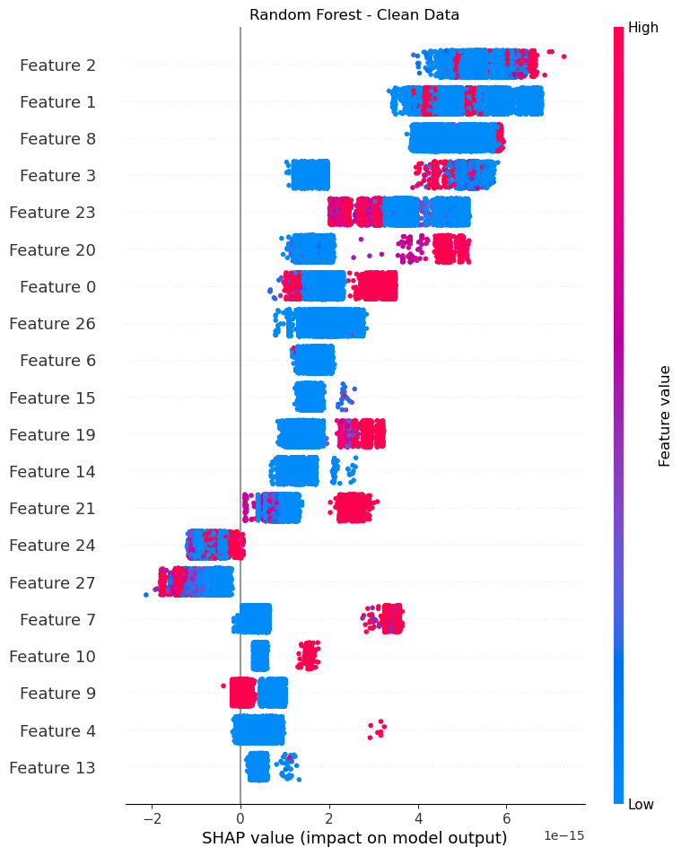

### Boundary Attack

### 

### 

### 

### 

### 

### 

### 

### 

### 

### **After Boundary Attack**

#### Key Observations:

* **Overall Accuracy Drop**: The accuracy on the adversarial samples is now just 20%, a significant drop from 41%, indicating that the attack has effectively confused the model.
* **Confusion Matrix**:
  + The attack samples primarily confuse the model into predicting mscan, and no correct classifications are made for guess_passwd, neptune, normal, or saint.
  + This misclassification pattern suggests that the Boundary Attack has successfully perturbed the samples close to the decision boundary, pushing them toward a single class (mscan) regardless of their original category.
* **Classification Report**:
  + **High Precision but Low Recall for mscan**: The model’s recall is only 20% across classes, while precision remains high. This high precision but low recall indicates that the model is confidently misclassifying samples as mscan.
  + **Complete Misclassification of Some Classes**: Classes such as normal, guess_passwd, neptune, and sainthave zero recall, meaning the model fails to correctly identify any samples from these classes under adversarial conditions.

#### Interpretation:

* **Adversarial Vulnerability**: The Boundary Attack has made samples from diverse classes appear similar to one another, highlighting the model’s vulnerability to boundary-based adversarial perturbations. It reveals that the model’s decision boundaries are not robust, as small perturbations push samples across these boundaries, especially for minority classes.
* **Model Bias Towards Certain Classes**: The model appears biased towards predicting specific classes (like mscan) under attack conditions, indicating that some classes have weak decision boundaries that overlap under perturbations.

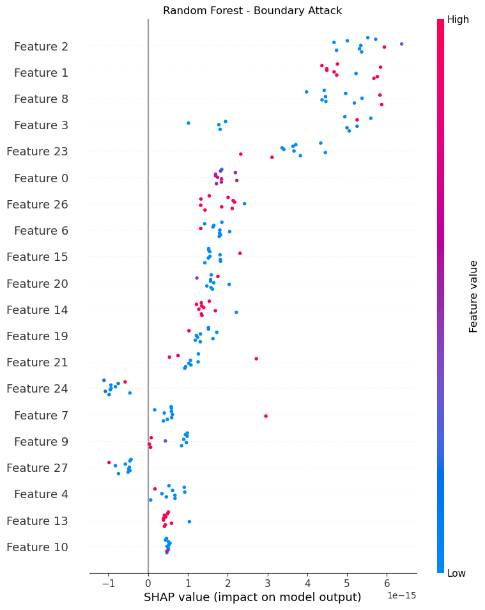

### HopSkiJump Attack

#### **HopSkipJump Attack Performance**:

* + **Similar Impact as Boundary Attack**: The HopSkipJump Attack has the same effect on accuracy, reducing it to 20%, with similar precision and recall patterns for affected classes.
  + **Misclassification Pattern**: Similar to the Boundary Attack, mscan is predicted frequently, leading to misclassification for most of the attacked classes.
  + **Class-Specific Results**: Like the Boundary Attack, classes guess_passwd, neptune, normal, and saint have zero recall, indicating that these samples are misclassified under the HopSkipJump Attack as well.

#### Interpretation of Results

1. **Consistency in Adversarial Vulnerability**:
   * Both attacks (Boundary and HopSkipJump) have a similar impact on the model, reducing its accuracy to 20% and making it heavily biased toward predicting a single class (mscan). This pattern is a strong indicator of the model's lack of robustness in handling adversarial perturbations.
2. **High Precision with Low Recall**:
   * In both adversarial cases, while the model maintains high precision in certain classes (like mscan), it struggles with recall across almost all other classes, indicating that it is easily misled by adversarial examples to consistently predict a single class.
3. **Class Imbalance Effect**:
   * The clean data results reveal significant class imbalance issues, with many classes having zero recall even before the adversarial attacks. Under adversarial conditions, these issues are exacerbated, as the model is already underperforming for many minority classes.
4. **Impact of Attack Success**:
   * The successful degradation in performance under both attacks demonstrates the model's vulnerability, particularly for classes with small support. This vulnerability suggests that, without defenses like adversarial training or better handling of class imbalance, the model cannot maintain reliable performance under adversarial conditions.

## 

## 

## Model : SVM

### Clean Data

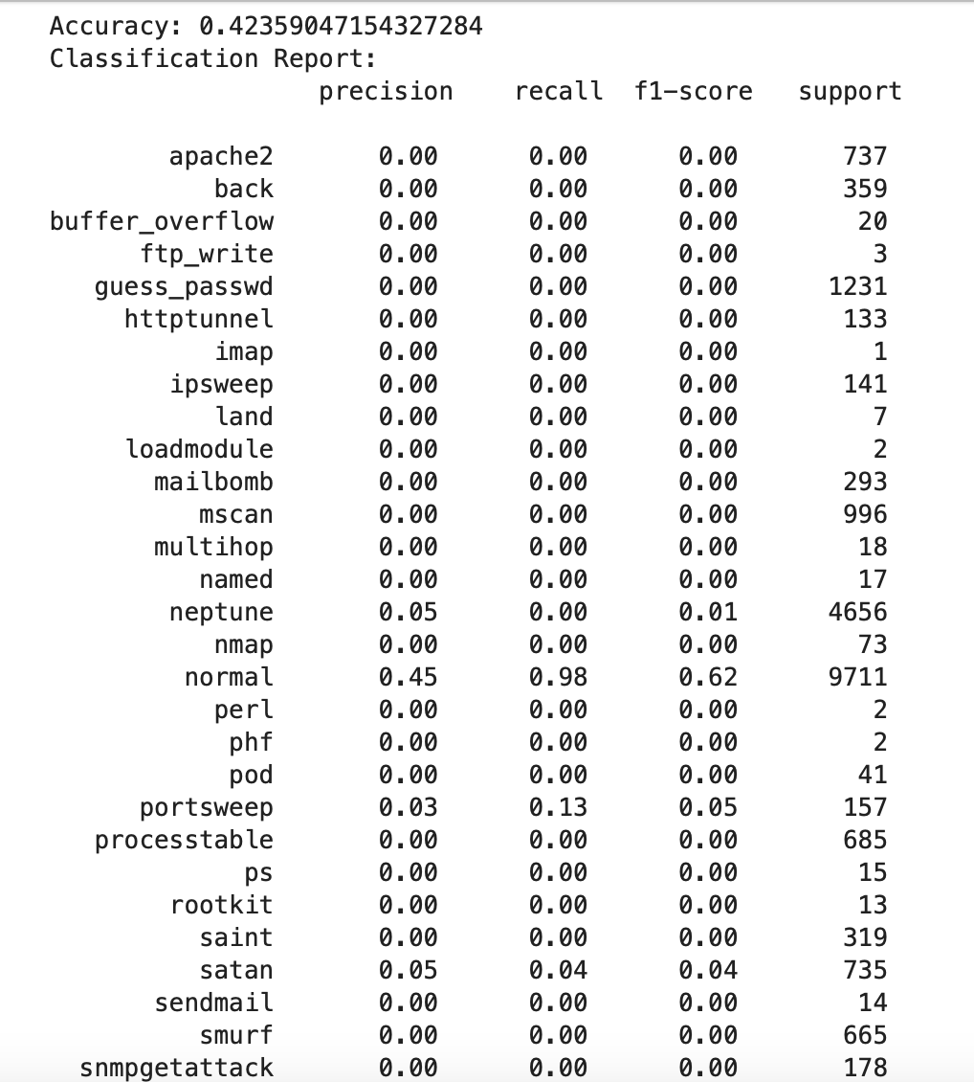

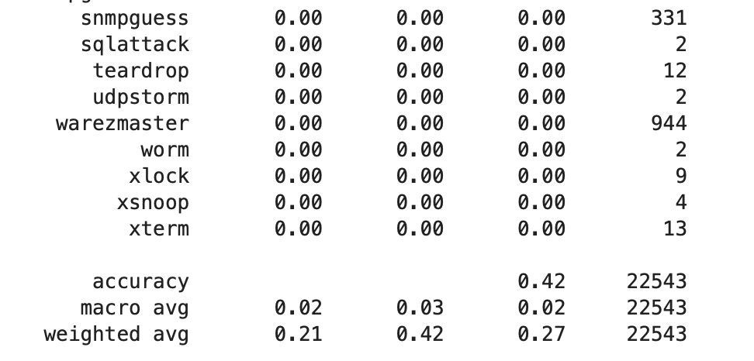

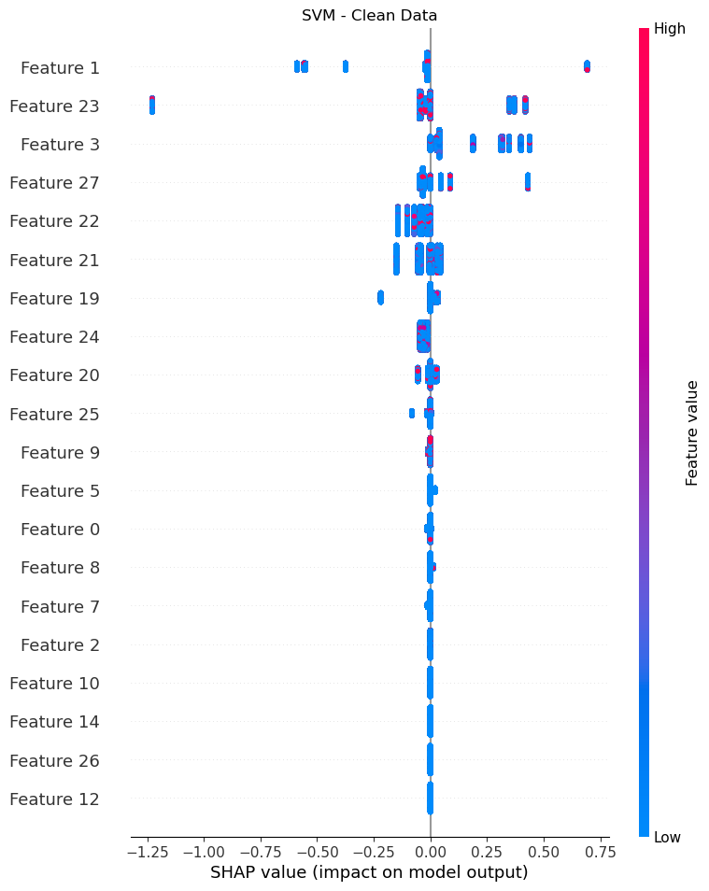

### Boundary Attack

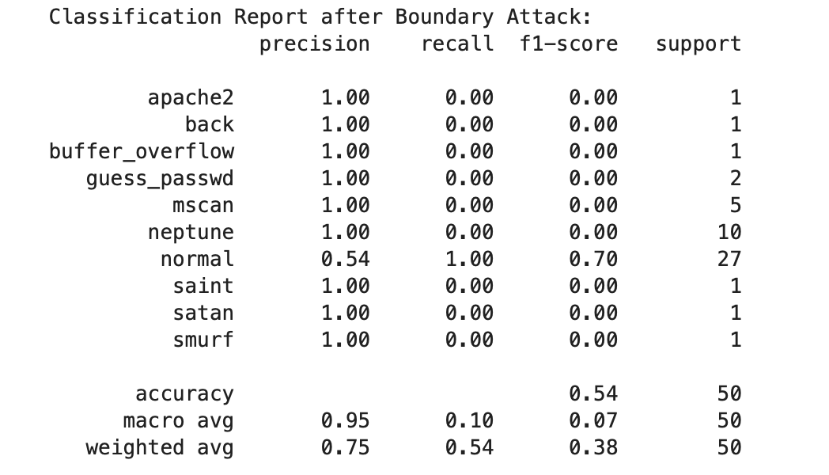

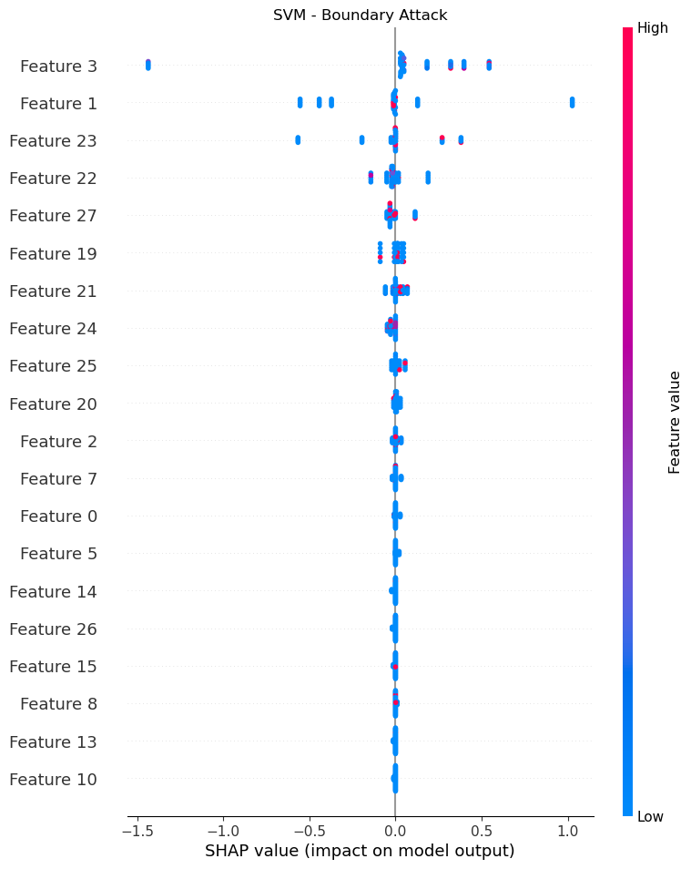

### HopSkiJump Attack

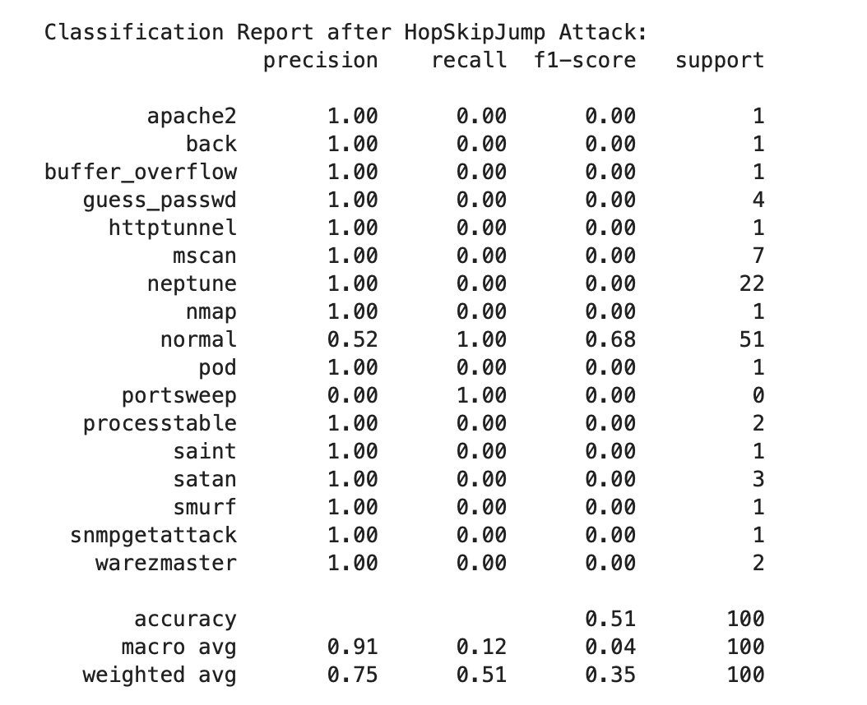

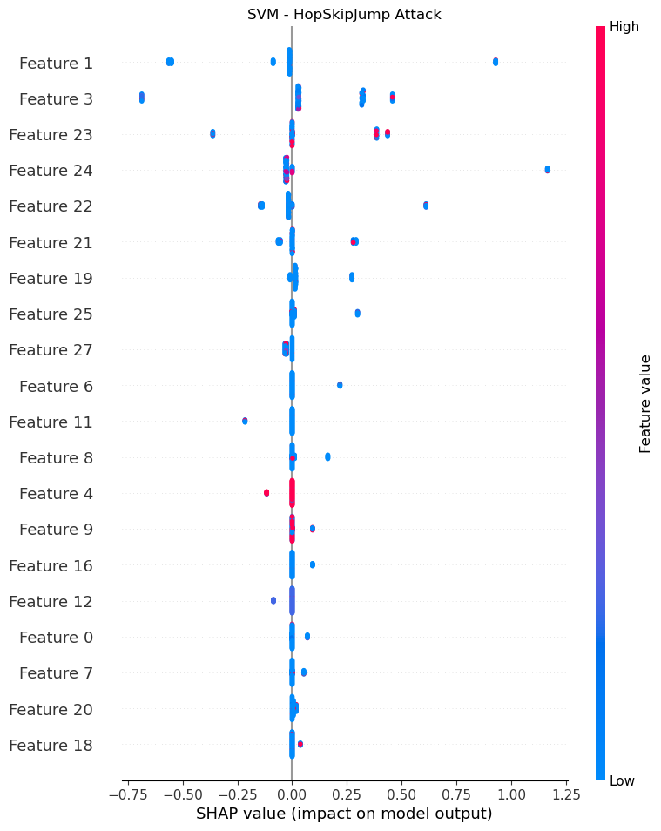

## Model : XGBoost

### Clean Data

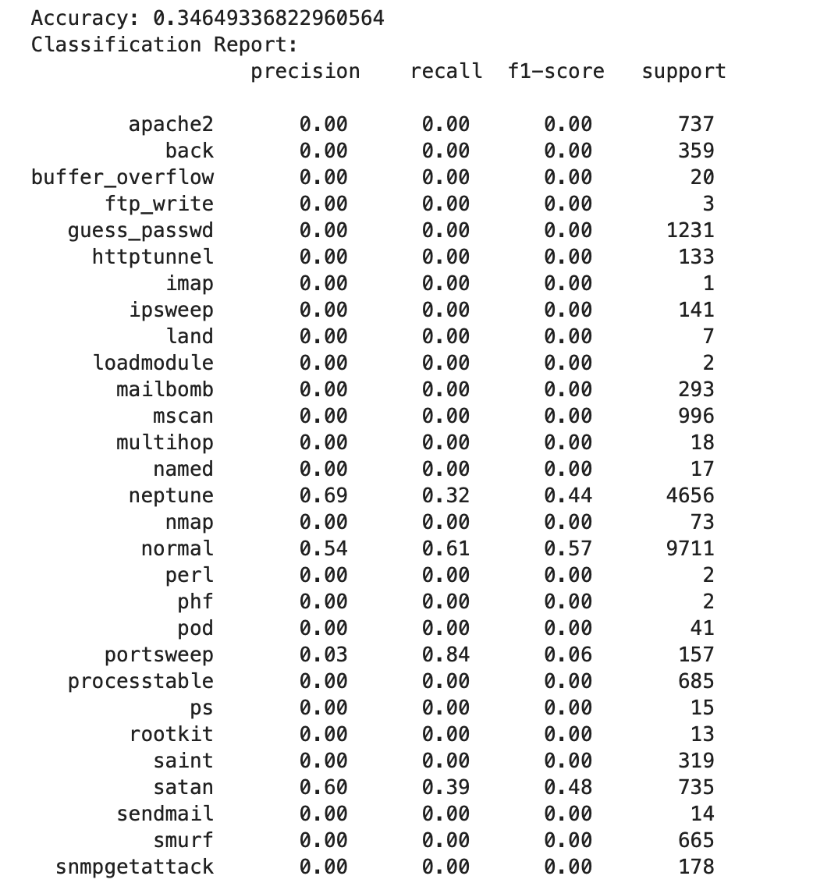

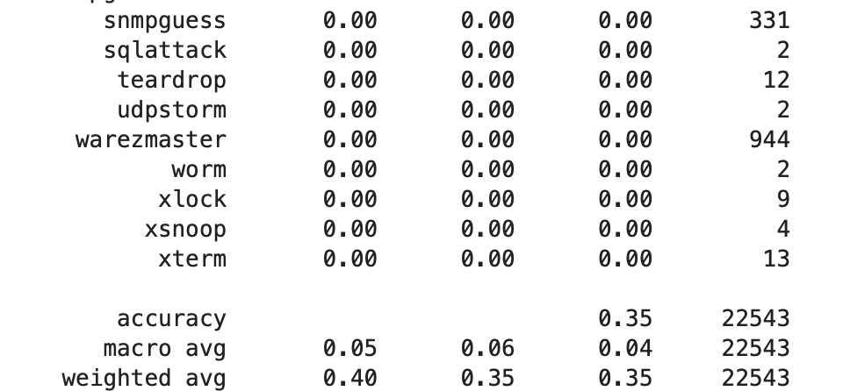

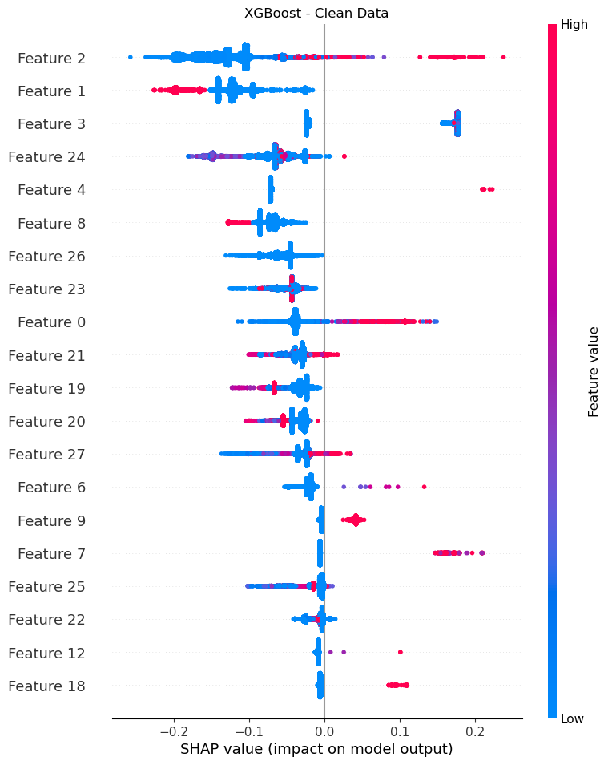

### Boundary Attack

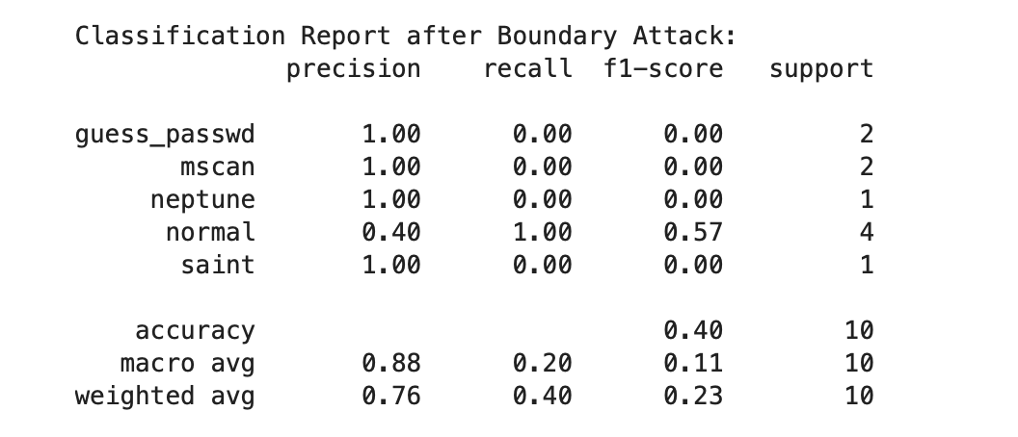

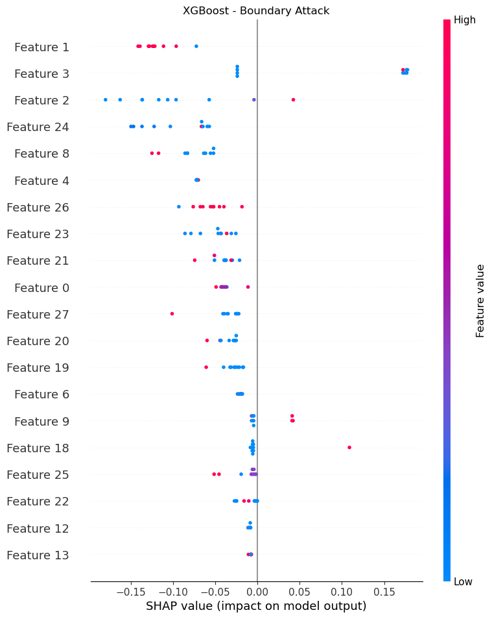

### HopSkiJump Attack

## 

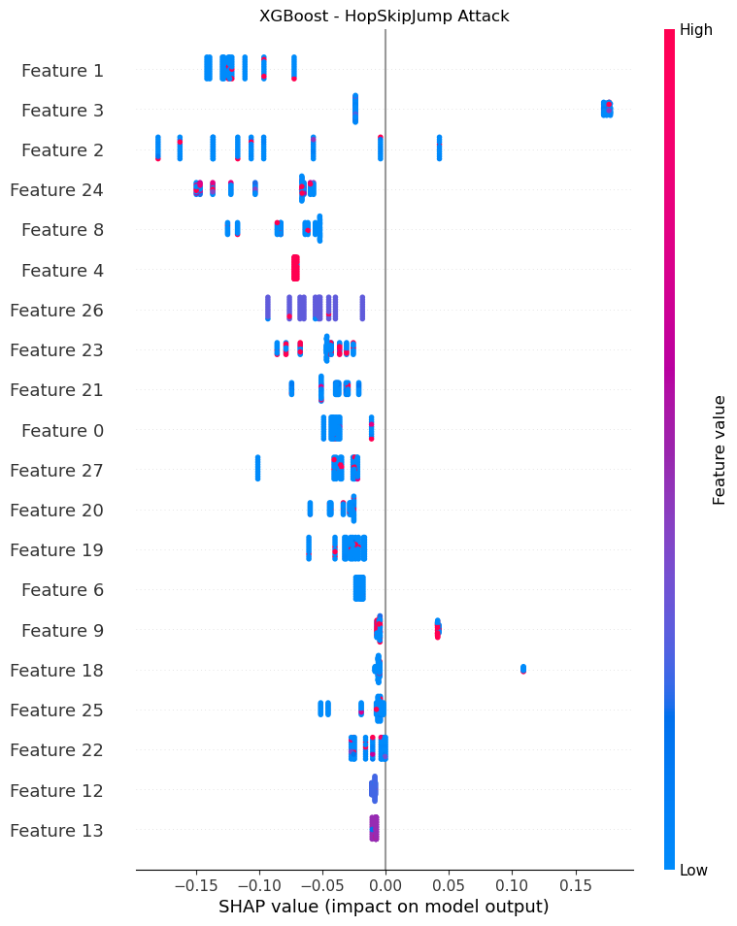

## Model : NN

### Clean Data

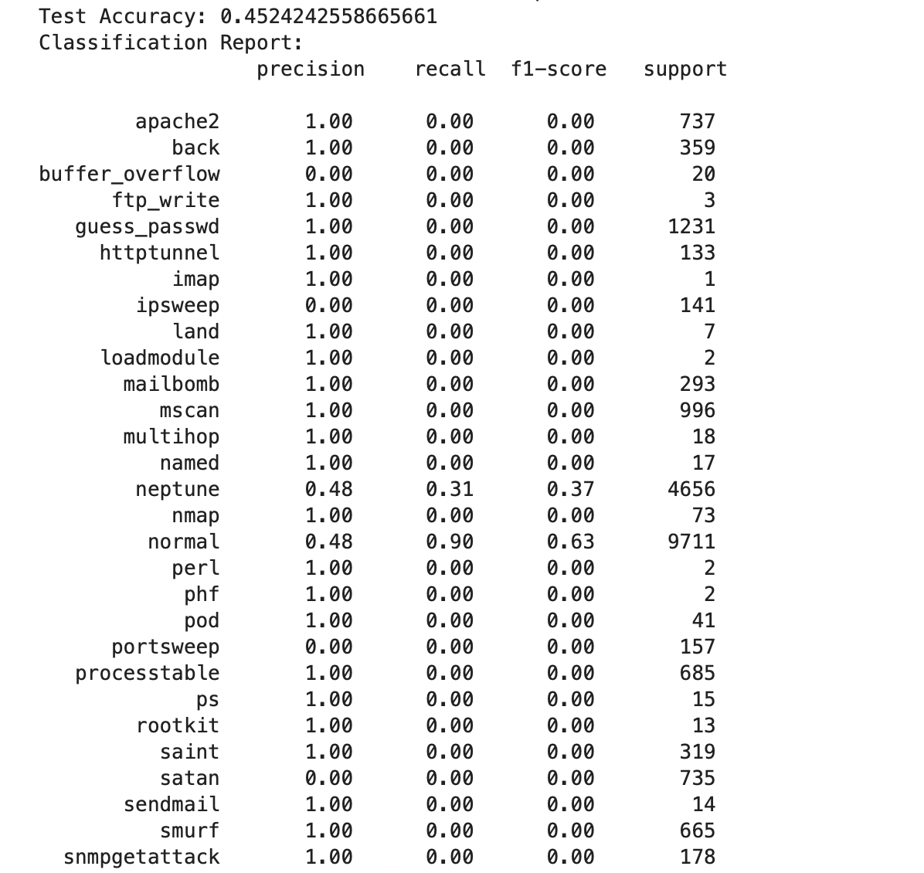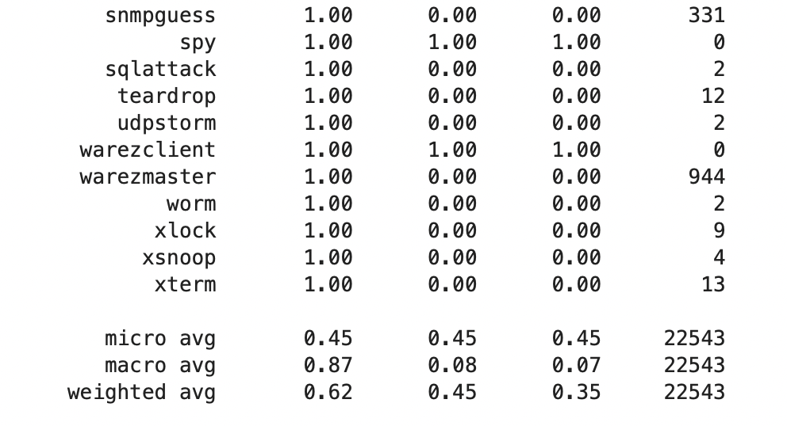

#### Performance on Clean Data

* **Test Accuracy**: 0.4524 (~45%).
* **Classification Report**:
  + The **normal class** achieved a recall of 0.90, indicating that the model detects normal samples relatively well.
  + However, most other classes have near-zero recall and precision, suggesting the model is struggling significantly with underrepresented classes, likely due to class imbalance.
  + **Key Issue**: The model seems biased toward predicting more common classes, especially normal and neptune, which makes it highly inaccurate for detecting rarer attack types (e.g., apache2, mailbomb).

**Takeaway**: While the model performs decently on normal, it is largely ineffective for a wide range of attack types due to class imbalance and a lack of generalization to less common classes.

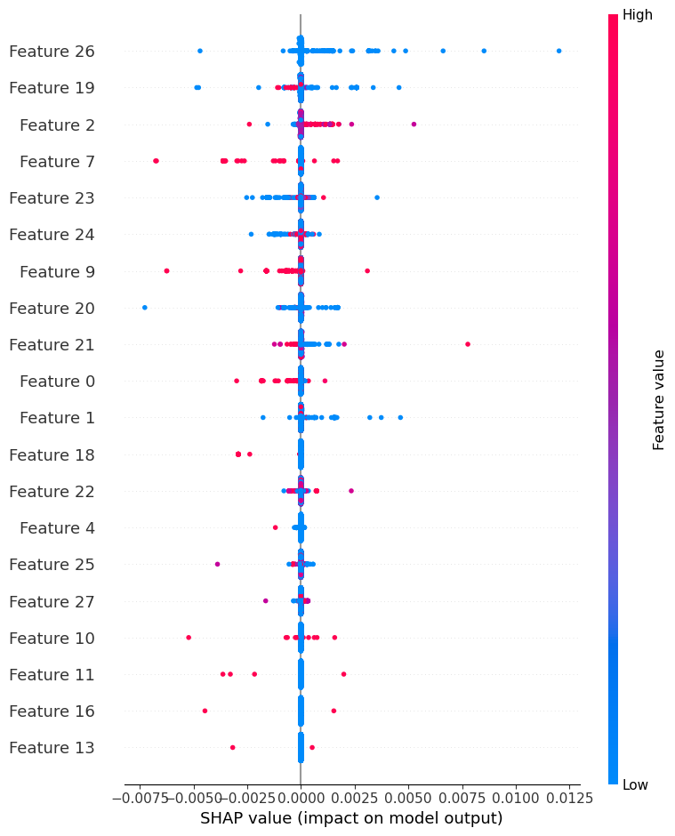

### FGSM Attack

#### Performance on Adversarial Examples (FGSM Attack)

* **Adversarial Accuracy**: 0.3331 (~33%).
* **Classification Report**:
  + The **recall and precision for most classes dropped further**, especially for neptune and normal. This reduction highlights the model's vulnerability to simple adversarial perturbations like FGSM, which affects its ability to detect both normal and attack classes accurately.
  + The model increasingly predicts dominant classes (normal and neptune), even more than in clean data, reflecting that the FGSM attack has successfully shifted its predictions.

**Takeaway**: The FGSM attack has exposed the model’s weak spots, specifically its heavy reliance on certain features, which can be easily perturbed to confuse it.

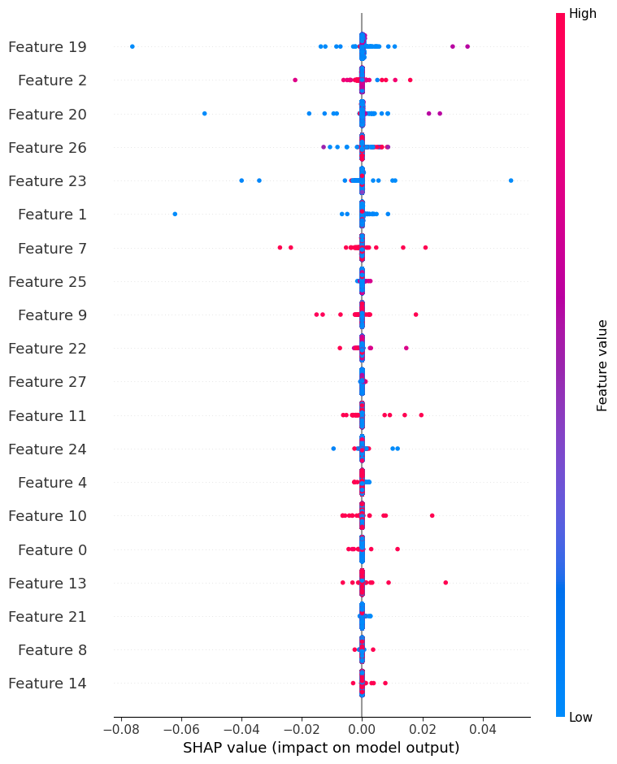

### PGD Attack

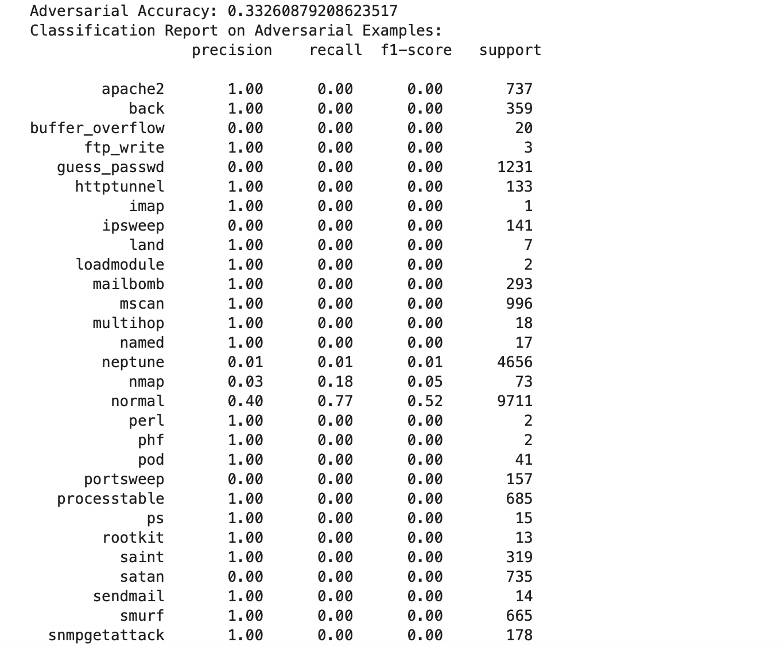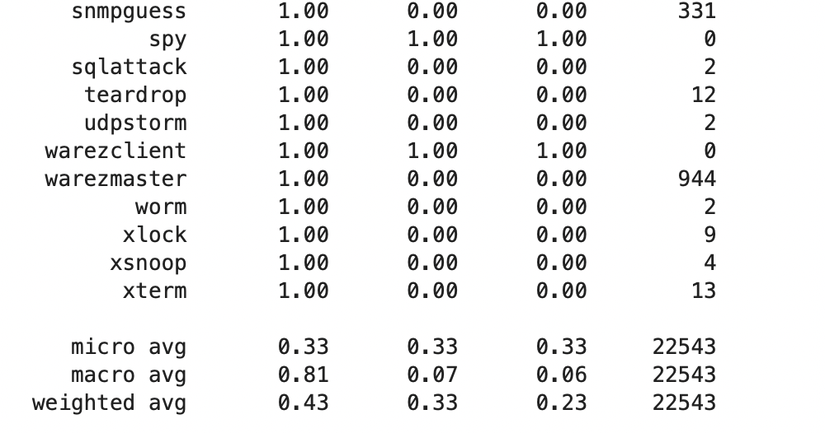

#### Performance on Adversarial Examples (PGD Attack)

* **Adversarial Accuracy**: 0.3326 (~33%).
* **Classification Report**:
  + The PGD attack resulted in even further degradation in accuracy and increased misclassification, as evidenced by a near-zero precision and recall for most attack classes.
  + The model becomes even more biased towards predicting the normal class, with almost no ability to accurately detect the less common attack classes.
  + **Impact of PGD**: The PGD attack, being iterative, is stronger and more targeted than FGSM, and this is evident in the model’s performance drop and tendency to misclassify.

**Takeaway**: The PGD attack has exacerbated the vulnerabilities revealed by FGSM, further reducing the model’s performance and indicating that the model is highly susceptible to iterative adversarial attacks.

#### Overall Analysis

1. **Class Imbalance**:
   * The model’s inability to generalize to underrepresented classes makes it particularly vulnerable, as it is biased towards the dominant classes, even on clean data.
2. **Adversarial Vulnerability**:
   * Both FGSM and PGD attacks significantly degrade the model’s performance, particularly for less frequent classes, showing that the model relies on features that are easily manipulated by adversarial perturbations.

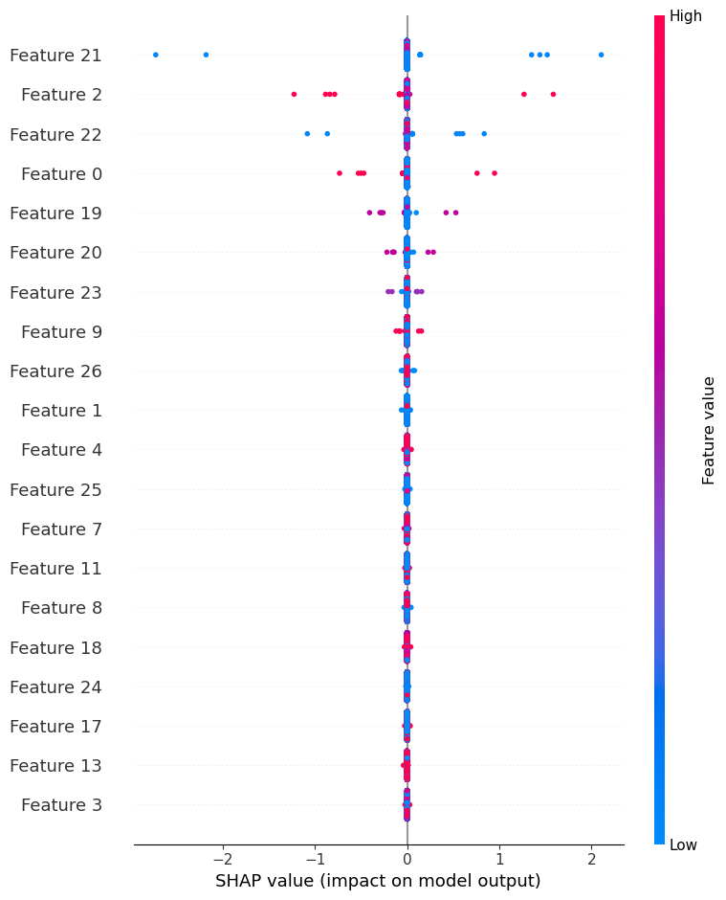

### Carlini&Wagner Attack

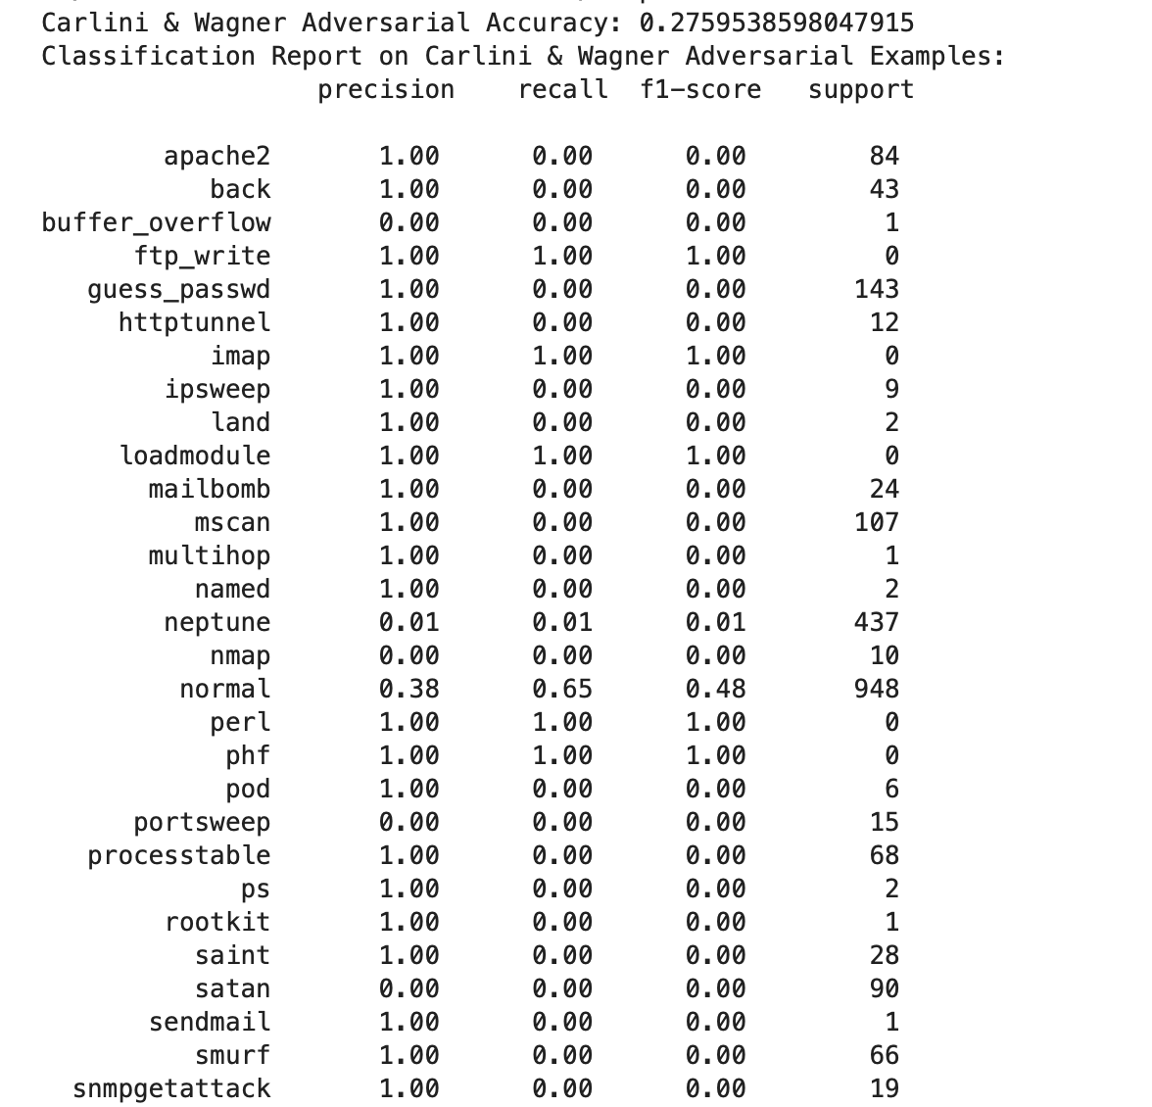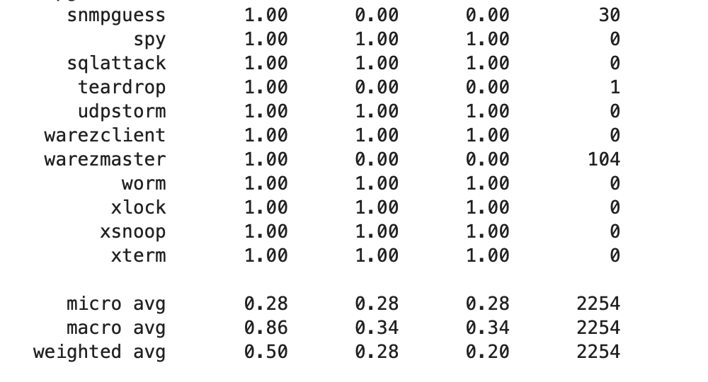

#### Carlini & Wagner Attack Analysis

1. **Overall Accuracy**:
   * **Adversarial Accuracy**: 0.276 (~28%), indicating a significant drop compared to the accuracy on clean data (which was around 45%).
   * This accuracy reduction shows that the C&W attack is more effective at deceiving the model compared to the FGSM and PGD attacks, which resulted in around 33% accuracy.
2. **Classification Report Insights**:
   * **Recall**: The recall for most classes is extremely low, with the model correctly identifying only a small fraction of samples from most attack classes.
     + The **normal** class shows a higher recall (0.65), indicating that the model can still detect a majority of normal samples, though much less effectively than on clean data.
     + Other classes, especially rare attack types like apache2, back, and mscan, have almost zero recall, meaning the model completely fails to identify them under the C&W attack.
   * **Precision**: Many classes have precision values of 1.0, but this is misleading because the model is simply not predicting those classes at all, leading to an inflated precision for classes with zero recall.
3. **Macro and Weighted Averages**:
   * **Macro Average**: Shows an overall low recall (0.34) across classes, indicating the model’s general inability to recognize various attack types under adversarial conditions.
   * **Weighted Average**: The weighted averages also reflect the model’s bias towards the more frequent classes, resulting in a low f1-score (0.20) for the entire dataset.

#### Comparison with FGSM and PGD Attacks

1. **Severity of Impact**:
   * The C&W attack appears more effective at reducing the model’s ability to detect attacks compared to FGSM and PGD. The drop in accuracy and recall across classes is more pronounced with the C&W attack.
   * **PGD**: Iterative like C&W but less effective in this case, with the model retaining some accuracy.
   * **FGSM**: A faster, less targeted attack than C&W and PGD, showing slightly better performance in terms of recall and f1-score than C&W.
2. **Bias Towards Dominant Classes**:
   * In all attacks, the model tends to predict the normal class more frequently, especially as the adversarial strength increases.
   * The C&W attack shows the strongest effect here, with the model becoming even more biased towards the normal class and failing to recognize most attack types.
3. **Effectiveness on Underrepresented Classes**:
   * The C&W attack particularly exposes the model’s vulnerability with underrepresented classes, as they are almost completely misclassified or ignored.
   * This effect is stronger with C&W than with FGSM or PGD, underscoring the attack’s effectiveness in disrupting the model’s understanding of class boundaries.

#### Key Takeaways

1. **Model Vulnerability**: The model is highly vulnerable to optimization-based attacks like C&W, which are designed to find minimal perturbations to fool the model.
2. **Imbalance in Class Detection**: The severe imbalance in the model’s predictions (favoring normal and a few attack classes) indicates that class imbalance remains a significant issue. Incorporating class-balancing techniques and retraining with adversarial examples could help mitigate this vulnerability.
3. **Need for Robustness Training**: Adversarial training, particularly using C&W and PGD examples, may improve the model’s resilience by teaching it to recognize perturbed patterns within each class boundary.

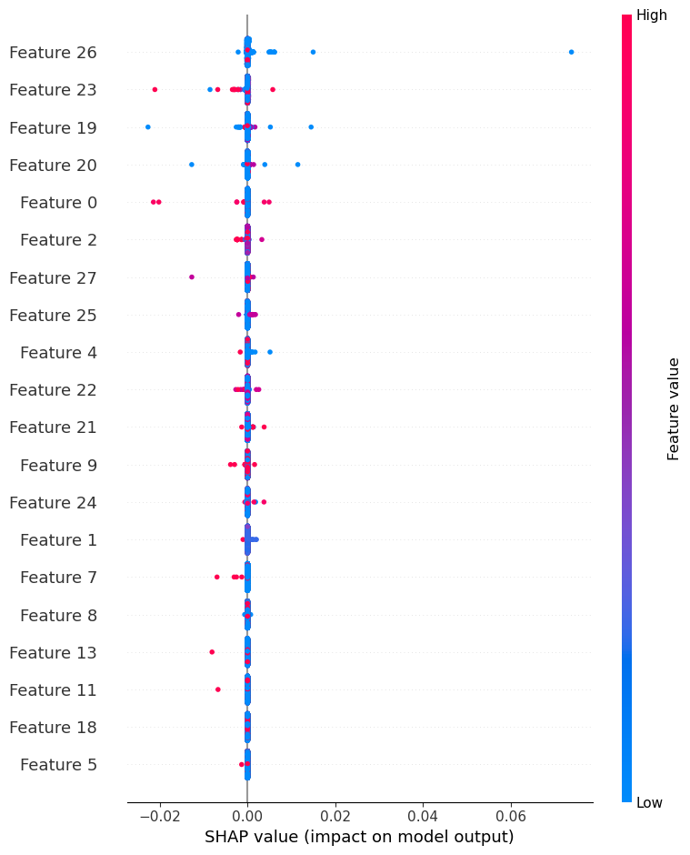

## Model : MLP

### Clean Data

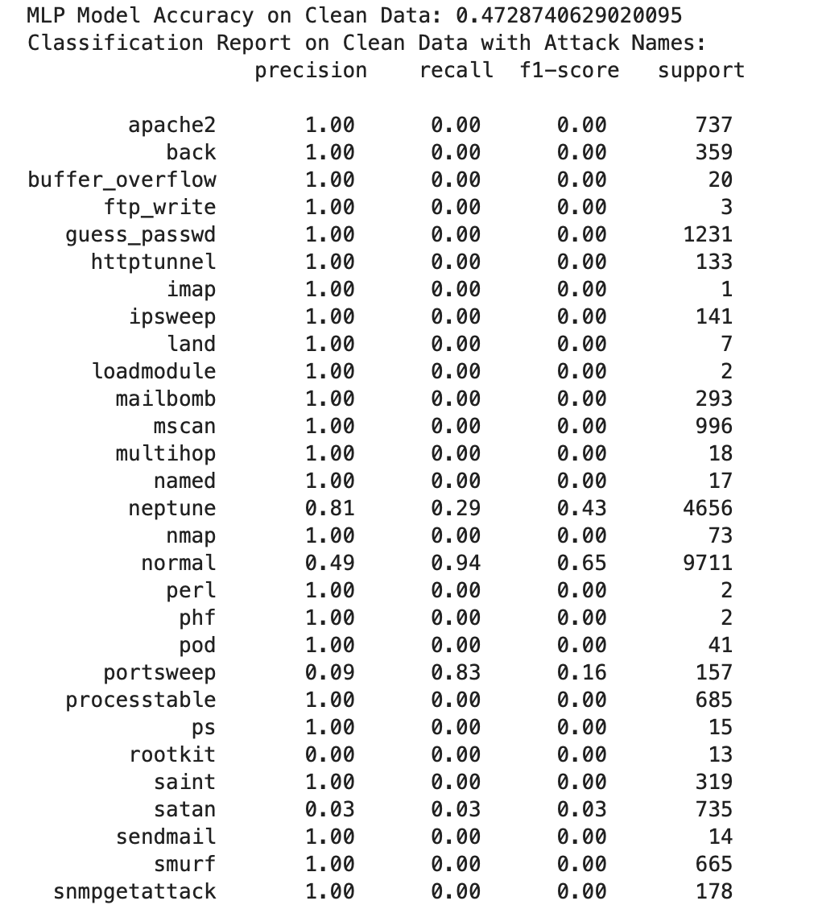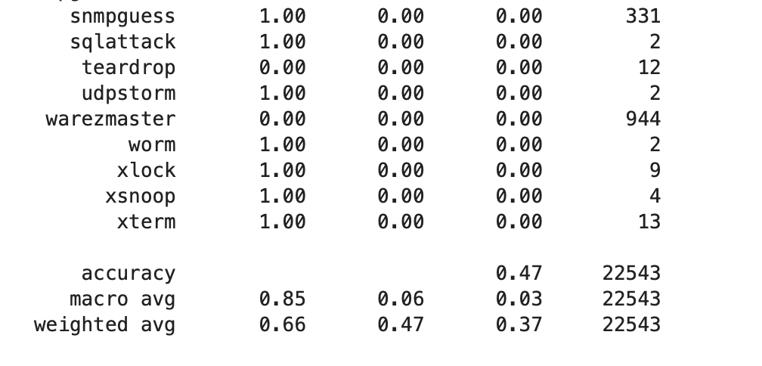

#### Performance on Clean Data

* **Accuracy**: 47.29%
* **Observations**:
  + The model performs reasonably well on clean data, achieving moderate precision and recall for the normalclass (0.94 recall) and some improvement in other frequent classes like neptune.
  + Many rare classes (e.g., apache2, back, guess_passwd, mscan) are poorly classified, with nearly zero recall. This indicates that the model struggles with imbalanced data.
  + The macro average recall is low at 6%, reflecting poor generalization across less frequent attack classes.

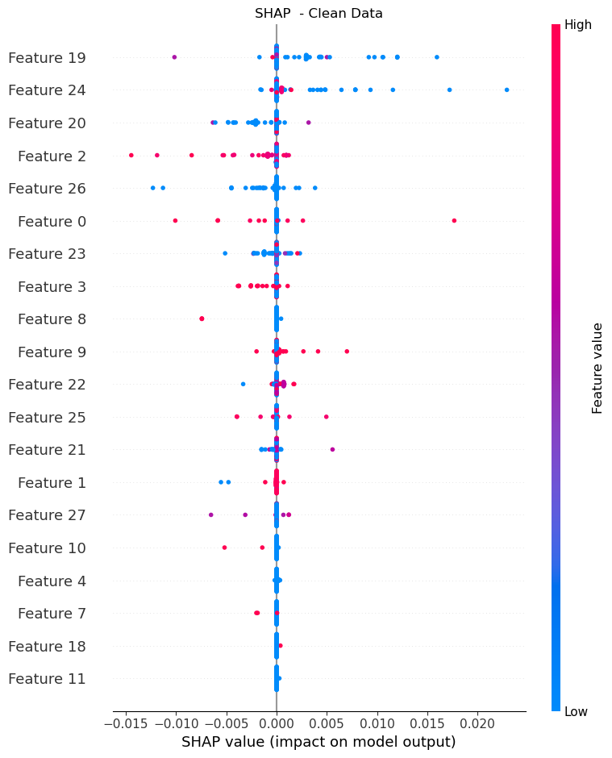

### FGSM Attack

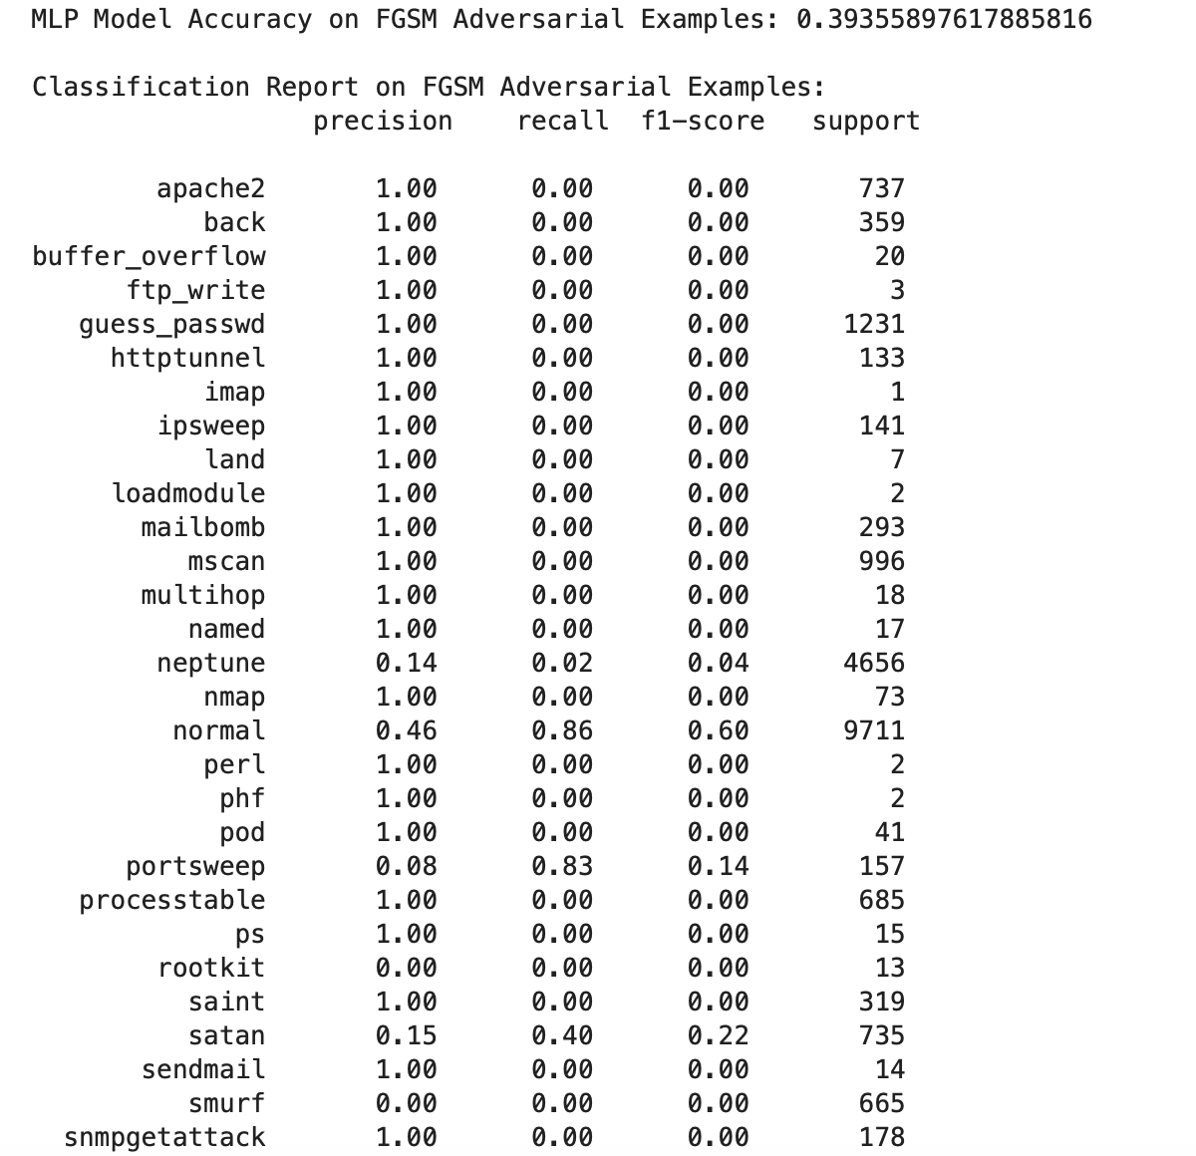

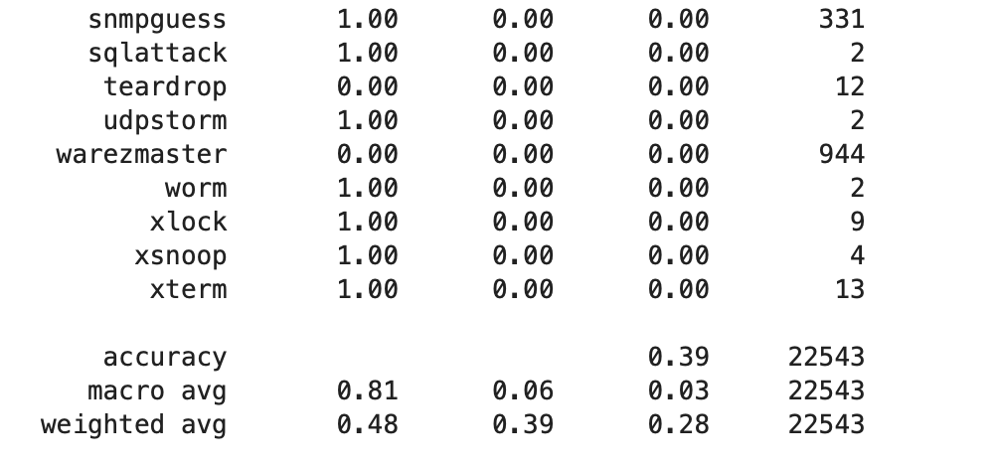

#### FGSM Attack

* **Accuracy**: 39.36%
* **Observations**:
  + The FGSM attack causes a drop in accuracy by approximately 8%, demonstrating the model’s vulnerability to this single-step attack.
  + The normal class recall is slightly reduced but still high (0.86), indicating that the model retains some ability to classify non-adversarial instances correctly.
  + Certain classes (portsweep with 0.83 recall and satan with 0.40 recall) are better classified than others, while most classes continue to suffer from low or zero recall.
  + The macro average recall is low (6%), highlighting the attack's effectiveness in confusing the model across various classes.

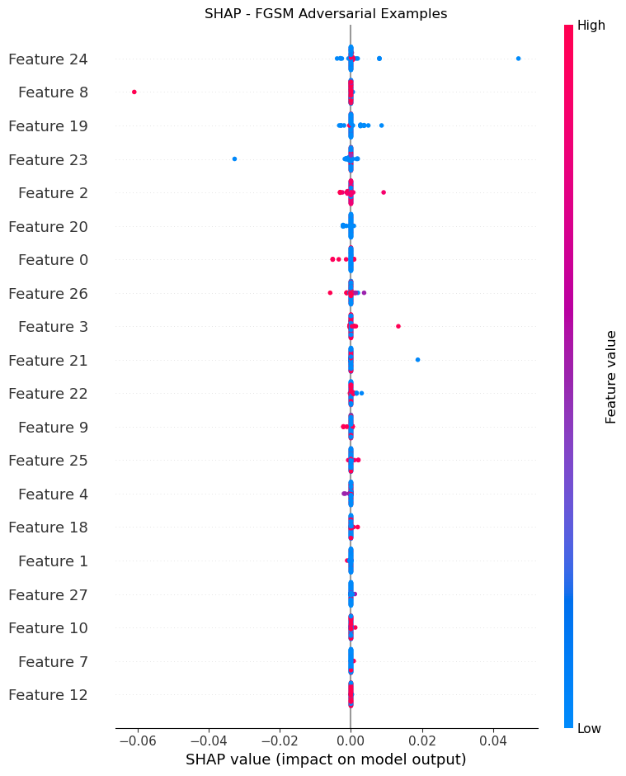

### PGD Attack

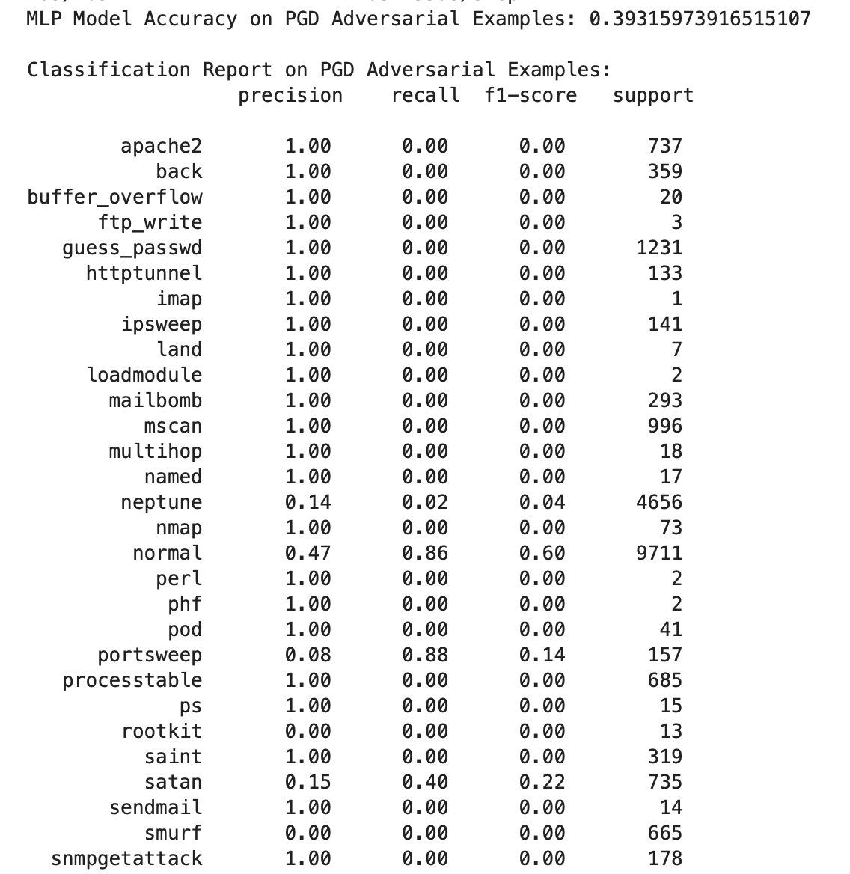

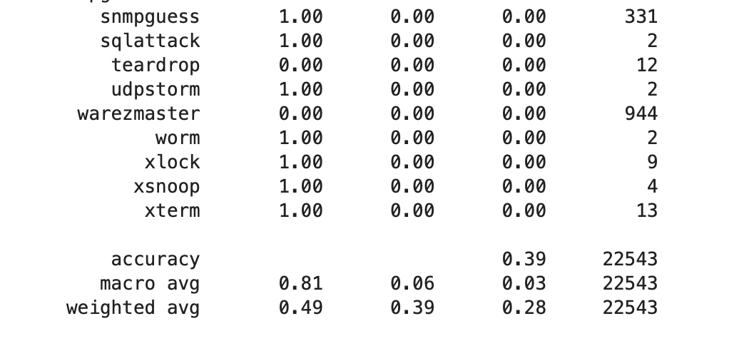

#### PGD Attack

* **Accuracy**: 39.32%
* **Observations**:
  + The PGD attack shows a similar impact as FGSM, reducing accuracy to nearly the same level.
  + The model performs slightly better on portsweep (0.88 recall), suggesting that this iterative attack makes some patterns easier to identify for specific classes.
  + Similar to the FGSM, most classes, especially the rare ones, have zero recall, while the normal class still has relatively high recall (0.86).
  + The macro average recall remains low at around 6%, showing that the model is highly susceptible to PGD perturbations.

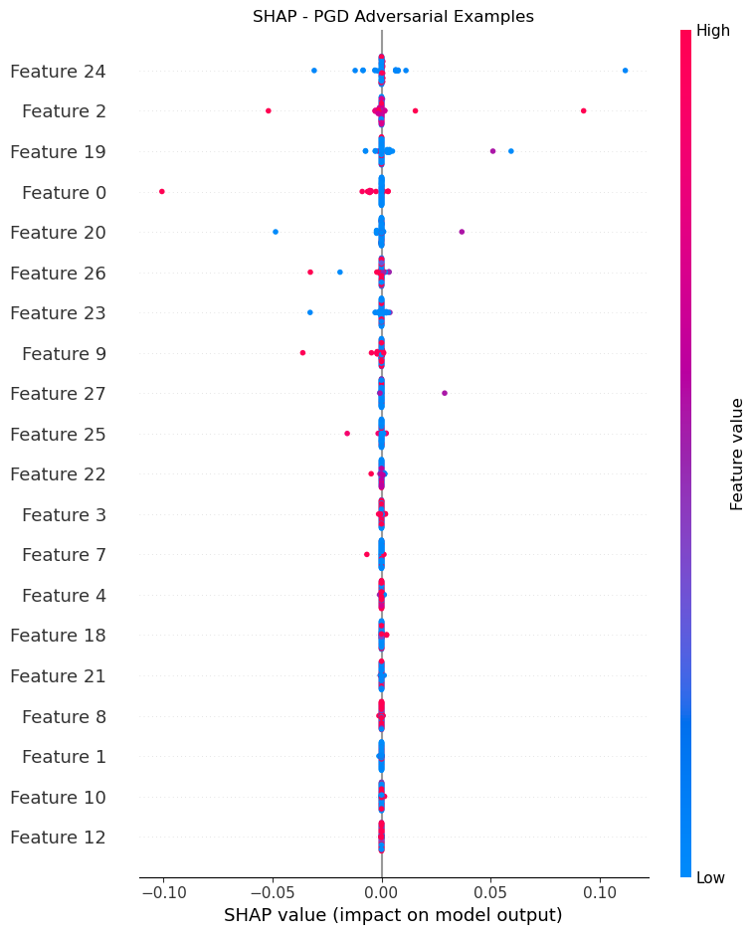

### Carlini&Wagner Attack

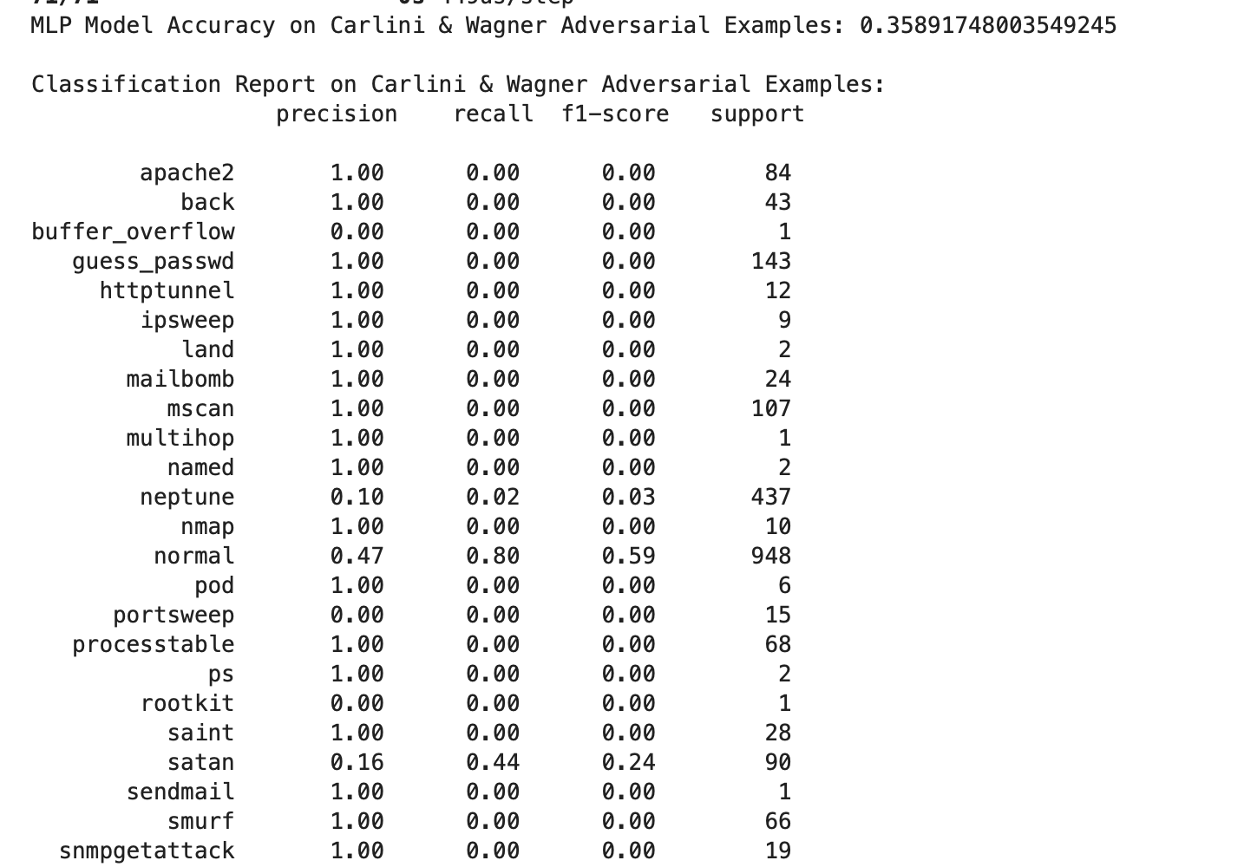

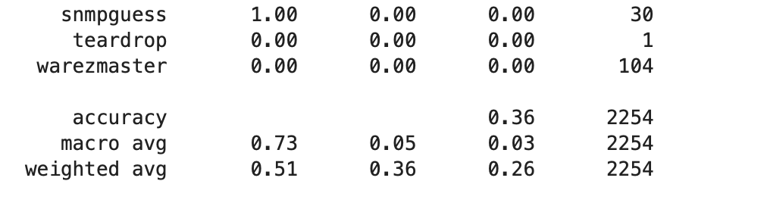

#### Carlini & Wagner (C&W) Attack

* **Accuracy**: 35.89%
* **Observations**:
  + The C&W attack, which minimizes perturbations while being highly targeted, further lowers the model accuracy.
  + The normal class has slightly reduced recall (0.80) compared to FGSM and PGD, indicating that C&W is more effective at confusing even the most well-learned classes.
  + The class satan has relatively better recall (0.44) under C&W, although overall recall across classes is poor.
  + Macro average recall is at a very low 5%, indicating that C&W significantly disrupts the model's ability to generalize across attack classes, even on a smaller subset of test data.

### **Summary of Results**

| **Metric** | **Clean Data** | **FGSM Attack** | **PGD Attack** | **Carlini & Wagner** |
| --- | --- | --- | --- | --- |
| **Accuracy** | 47.29% | 39.36% | 39.32% | 35.89% |
| **Normal Class Recall** | 0.94 | 0.86 | 0.86 | 0.80 |
| **Portsweep Class Recall** | 0.83 | 0.83 | 0.88 | 0.00 |
| **Satan Class Recall** | 0.03 | 0.40 | 0.40 | 0.44 |
| **Macro Average Recall** | 6% | 6% | 6% | 5% |
| **Weighted Average Recall** | 47% | 39% | 39% | 36% |

### **Key Takeaways**

* **Vulnerability Across Attacks**: The model shows significant susceptibility to all attacks, with a substantial drop in accuracy from 47.29% on clean data to 35.89% under C&W.
* **Class-Specific Resilience**: Some classes like normal and satan retain higher recall under attack, while rare attack classes remain vulnerable with near-zero recall.
* **Impact of Attack Complexity**: The iterative nature of PGD and the optimization of C&W make them more targeted, with C&W yielding the lowest accuracy, showcasing the model’s vulnerability to advanced attacks.

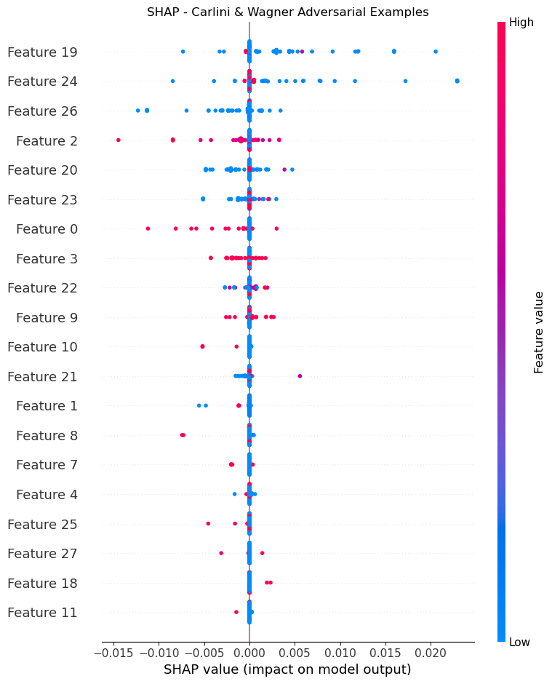

## Model : CNN

### Clean Data

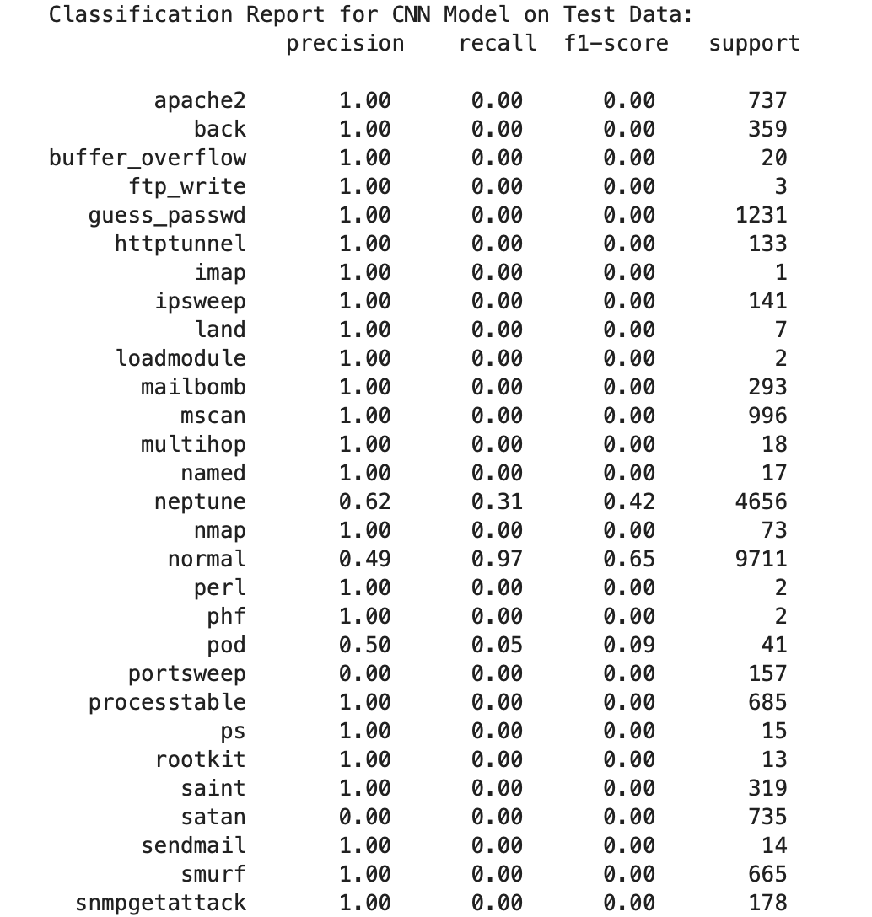

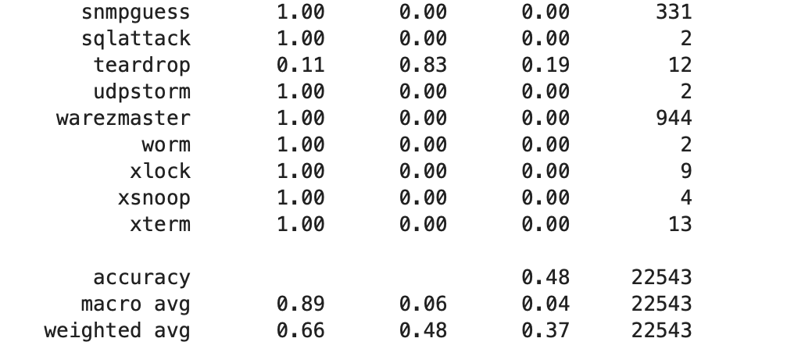

#### Performance on Clean Test Data

#### Key Metrics

* **Accuracy**: 48%
* **Macro Average**:
  + Precision: 0.89
  + Recall: 0.06
  + F1-Score: 0.04
* **Weighted Average**:
  + Precision: 0.66
  + Recall: 0.48
  + F1-Score: 0.37

#### Detailed Analysis

* **High Performance on "normal" Class**: The model achieves 0.97 recall and a 0.65 f1-score for the "normal" class. This suggests that the model is highly tuned to detect normal instances, which likely boosts its overall accuracy since "normal" has a high support count (9711 instances).
* **Detection of Attacks**: Most attack classes have a precision of 1.00 but recall of 0.00, indicating the model’s failure to detect these attacks. Classes like "apache2," "back," and "guess_passwd" are severely under-represented in detection, with zero recall and f1-scores.
* **Exceptions**:
  + **"neptune" class**: Shows moderate performance with a precision of 0.62, recall of 0.31, and f1-score of 0.42. The model captures some instances of "neptune" attacks but lacks robust detection.
  + **"teardrop" class**: The model achieves a high recall of 0.83 for this class, but the precision is only 0.11, resulting in an f1-score of 0.19. This indicates the model sometimes predicts "teardrop" but with low precision, suggesting random or coincidental detections.

#### Conclusion for Clean Data

Overall, the model is biased toward detecting "normal" instances, with limited capability for recognizing attack patterns. The low recall and f1-scores for most attack types demonstrate that the model fails to generalize well across diverse classes of attacks.

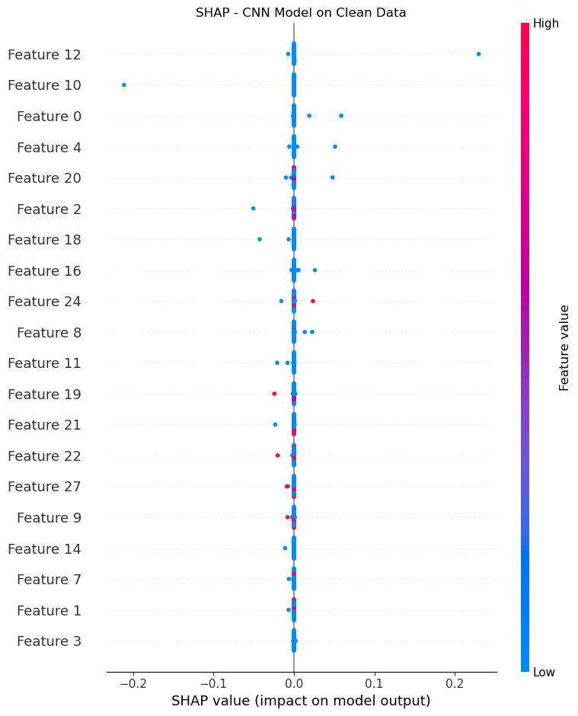

### FGSM Attack

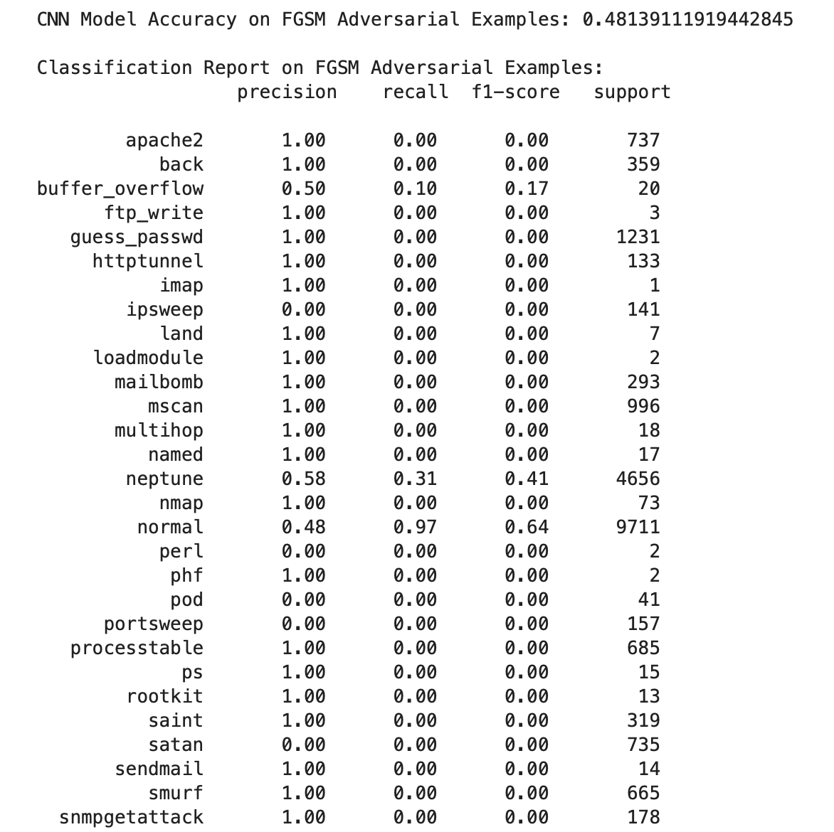

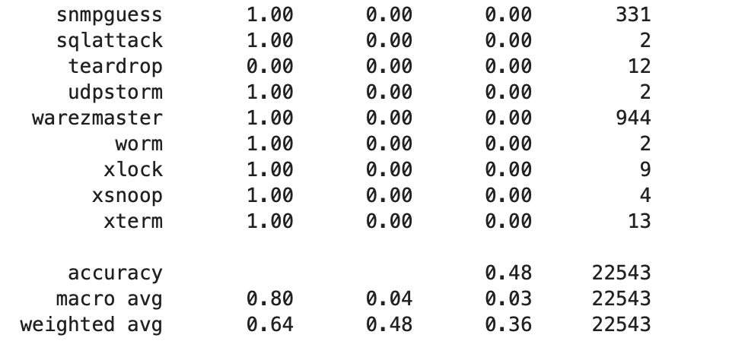

#### Performance on FGSM Adversarial Examples

#### Key Metrics

* **Accuracy**: 48.1%
* **Macro Average**:
  + Precision: 0.80
  + Recall: 0.04
  + F1-Score: 0.03
* **Weighted Average**:
  + Precision: 0.64
  + Recall: 0.48
  + F1-Score: 0.36

#### Detailed Analysis

* **Drop in Macro Precision**: The macro precision reduces from 0.89 to 0.80 under FGSM attacks, indicating that the model’s classification ability is compromised across multiple classes. This is a sign of vulnerability to adversarial attacks.
* **Class-Level Changes**:
  + **"buffer_overflow"**: This class shows a slight improvement in recall to 0.10, albeit with a low f1-score of 0.17. This suggests some ability to detect specific adversarial modifications in FGSM but not robustly.
  + **"neptune" and "normal" Classes**: Recall for these classes remains relatively high, with "neptune" at 0.31 and "normal" at 0.97. This indicates that the model still maintains its ability to classify “normal” and “neptune” with decent accuracy even under adversarial perturbation.
  + **Other Attack Classes**: For most other attack types, recall remains near zero, showing minimal improvement in detecting adversarially perturbed attacks.

#### Conclusion for FGSM Data

The model's accuracy and recall values suggest it struggles against FGSM examples, retaining only the ability to classify "normal" and a few other classes. The macro and weighted averages drop slightly, suggesting FGSM does impact the model’s ability to generalize across attacks.

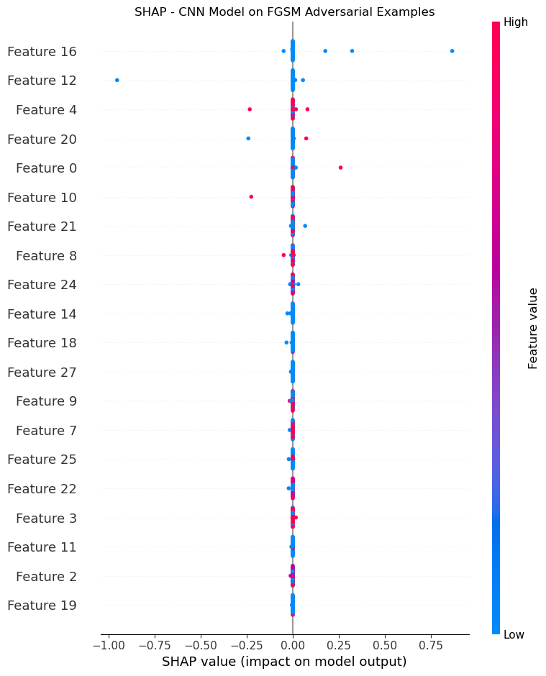

### PGD Attack

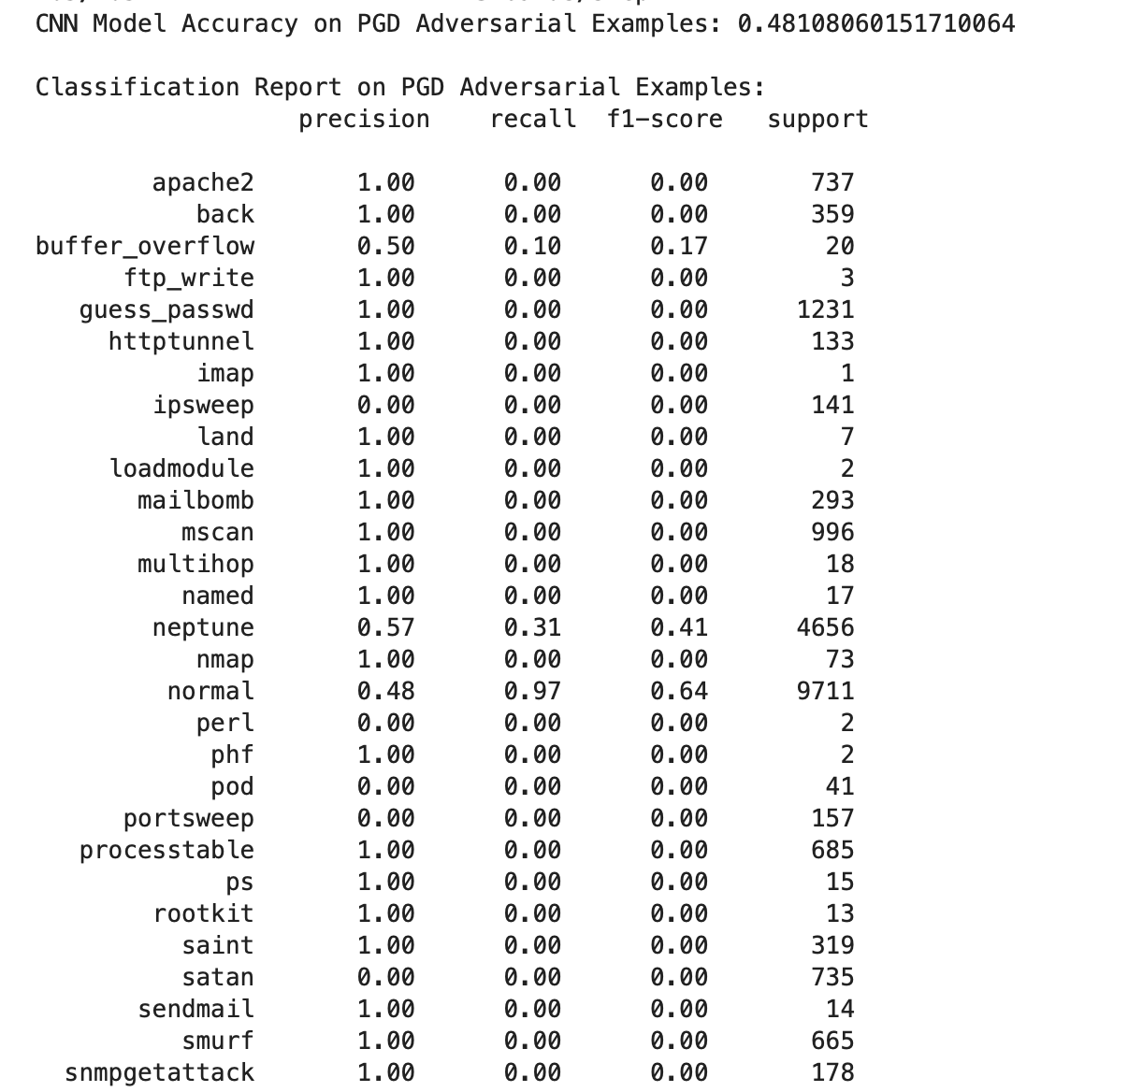

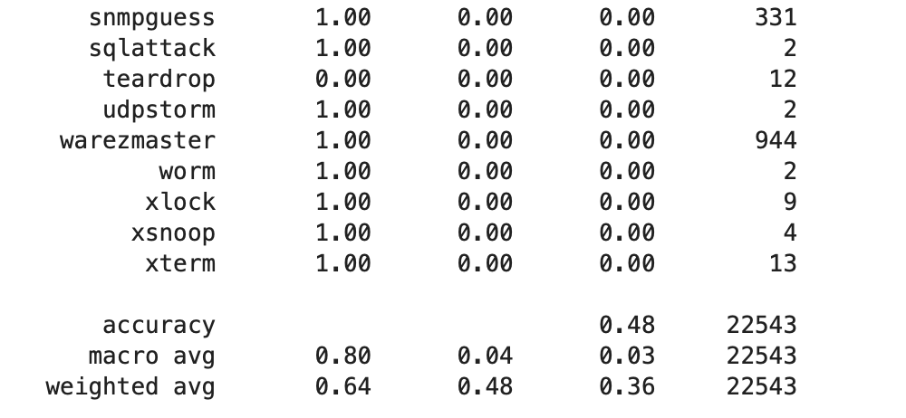

#### Performance on PGD Adversarial Examples

#### Key Metrics

* **Accuracy**: 48.1%
* **Macro Average**:
  + Precision: 0.80
  + Recall: 0.04
  + F1-Score: 0.03
* **Weighted Average**:
  + Precision: 0.64
  + Recall: 0.48
  + F1-Score: 0.36

#### Detailed Analysis

* **Consistency with FGSM Performance**: The model performs almost identically on PGD examples as it did on FGSM examples, with similar precision, recall, and f1-score values.
* **Notable Class Observations**:
  + **"normal" Class**: Recall remains at 0.97, keeping the model’s accuracy stable since the "normal" class has high support.
  + **Attack Classes**: Like in FGSM, most attack classes show zero recall, meaning the model fails to capture adversarial modifications effectively. A few minor classes like "buffer_overflow" maintain some recall (0.10), but this does not lead to significant improvements in overall model performance.
  + **"neptune" Class**: Recall of 0.31 and f1-score of 0.41, similar to the FGSM results, showing that the model remains slightly effective at detecting "neptune" attacks even under PGD perturbations.

#### Conclusion for PGD Data

PGD adversarial examples slightly affect the model's recall and precision, with most attack classes remaining undetected. The similarity in results between FGSM and PGD indicates that the model has comparable vulnerabilities to both adversarial techniques.

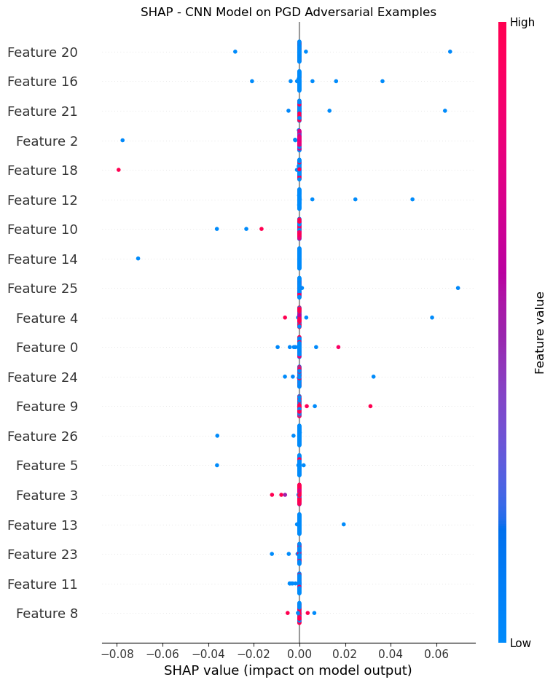

### Carlini&Wagner Attack

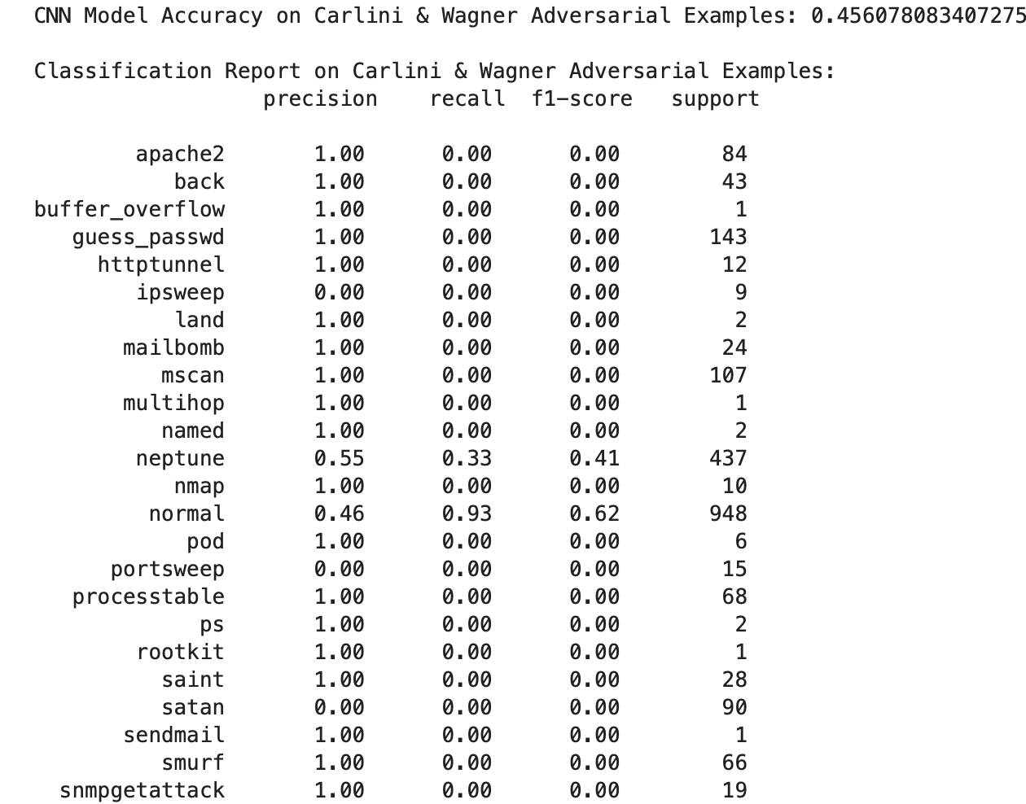

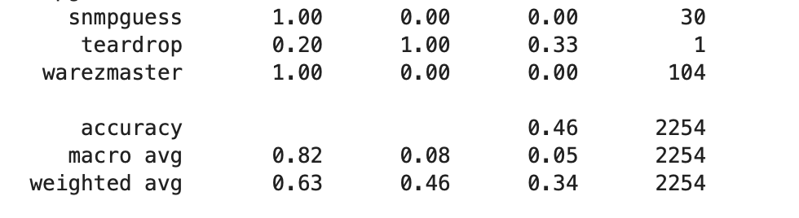

#### Performance on Carlini & Wagner (CW) Adversarial Examples

#### Key Metrics

* **Accuracy**: 45.6%
* **Macro Average**:
  + Precision: 0.82
  + Recall: 0.08
  + F1-Score: 0.05
* **Weighted Average**:
  + Precision: 0.63
  + Recall: 0.46
  + F1-Score: 0.34

#### Detailed Analysis

* **Further Decrease in Accuracy**: Accuracy drops to 45.6% under CW, indicating that this attack type affects the model’s performance more significantly than FGSM or PGD.
* **Class-Level Analysis**:
  + **"normal" Class**: Recall decreases to 0.93, still relatively high, but lower than in previous scenarios, reflecting the model’s increased difficulty in identifying normal instances under CW.
  + **"neptune" Class**: Similar recall (0.33) and f1-score (0.41) to other adversarial examples, indicating the model can partially identify CW-modified "neptune" samples.
  + **Unique Pattern in "teardrop" Class**: The recall for "teardrop" reaches 1.00 in CW examples, suggesting a potential overfitting or particular susceptibility in this class to adversarial noise.
  + **Other Attack Classes**: As with other scenarios, most attack classes retain near-zero recall and f1-scores, showing the model’s general inability to identify adversarial examples across diverse attack classes.

#### Conclusion for CW Data

CW adversarial examples reduce the model’s detection ability further, particularly impacting the "normal" class. The model shows some class-specific overfitting, such as in "teardrop," suggesting that CW can more effectively disguise or perturb samples in a way that confuses the model.

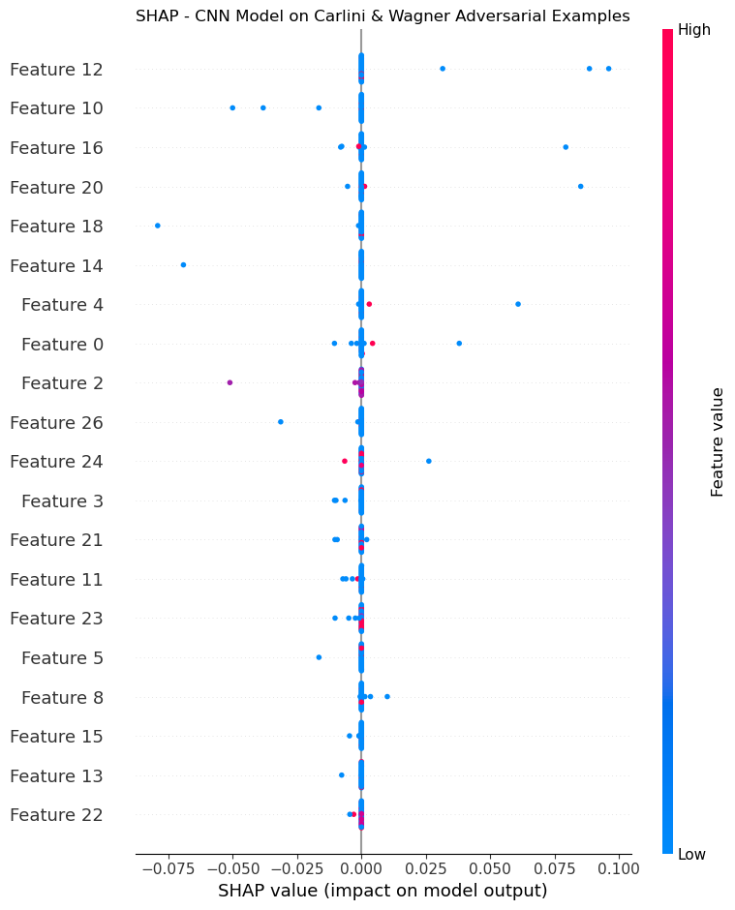

#### Summary and Comparison

| **Data Type** | **Accuracy** | **Macro Precision** | **Macro Recall** | **Macro F1-Score** | **Weighted Precision** | **Weighted Recall** | **Weighted F1-Score** |
| --- | --- | --- | --- | --- | --- | --- | --- |
| Clean Test Data | 48.0% | 0.89 | 0.06 | 0.04 | 0.66 | 0.48 | 0.37 |
| FGSM Adversarial | 48.1% | 0.80 | 0.04 | 0.03 | 0.64 | 0.48 | 0.36 |
| PGD Adversarial | 48.1% | 0.80 | 0.04 | 0.03 | 0.64 | 0.48 | 0.36 |
| Carlini & Wagner (CW) | 45.6% | 0.82 | 0.08 | 0.05 | 0.63 | 0.46 | 0.34 |

#### Comparative Summary

* **General Performance**: The model maintains high recall and precision only for the "normal" class across all data types. Most attack classes suffer from low recall and f1-scores in all scenarios.
* **Adversarial Impact**:
  + **FGSM and PGD**: Both adversarial examples have similar effects on the model, reducing accuracy slightly and yielding almost identical metrics.
  + **Carlini & Wagner**: CW examples show the most significant impact on accuracy and weighted metrics, indicating a more sophisticated adversarial effect that disrupts the model’s ability to detect "normal" and certain attack classes.
* **Model Vulnerability**: The low recall values across attack types suggest that the model is highly vulnerable to both FGSM and PGD attacks and even more so to CW attacks, reflecting a need for adversarial training and improved robustness across multiple classes.

In conclusion, the CNN model shows limitations in detecting diverse attack types, with high dependency on the "normal" class and significant susceptibility to all forms of adversarial attacks, particularly the Carlini & Wagner method.